Y10 WORK BOOKLET
(F)

Name: _________

ENGLISH

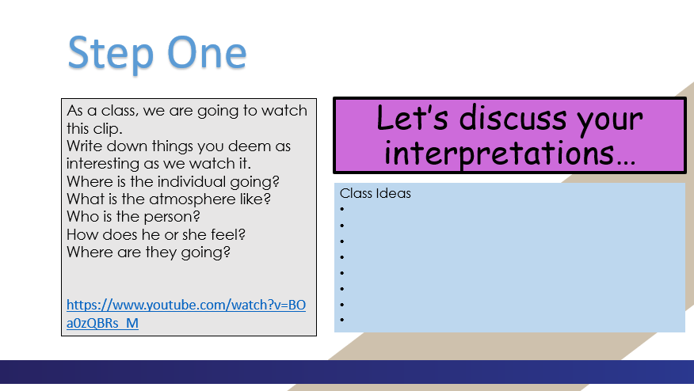

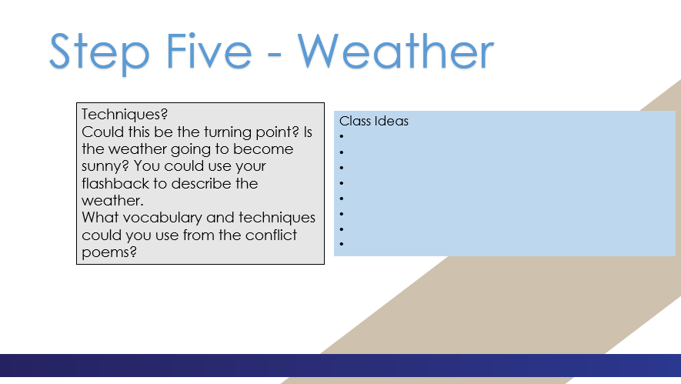

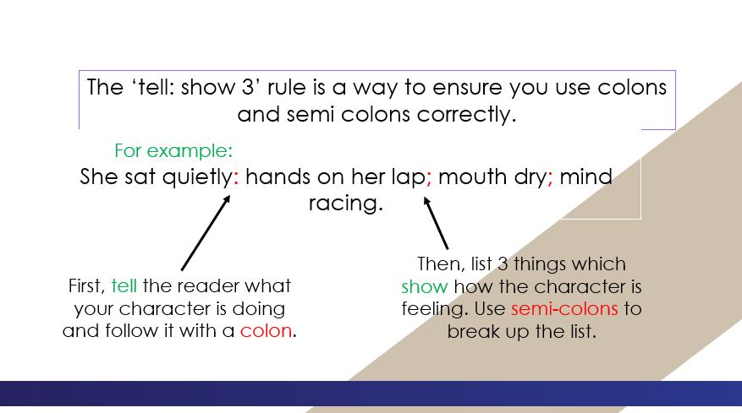

______________________________________________________________________________________________________________________________________________________________________________________________________________________________________________________________________________________________________________________________________________________________________________________________________________________________________________________________________________________________________________________________________________________________________________________________________________________________________________________________________________________________________________________________________________________________________________________________________________________________________________________________________________________________________________________________________________________________________________________________________________________________________________________________________________________________________________________________________________________________________________________________________________________________________________________________________________________________________________________________________________________________________________________________________________________________________________________________________________________________________________________________
____________________________________________________________________________________________________________________________________________________________________________________________________________________________________________________________________________________________________________________________________________________________________________________________________________________________________________________________________________________________________________________________________________________________________________________________________________________________________________________________________________________________________________________________________________________________________________________________________________________________________________________________________________________________________________________________________________________________________________________________________________________________________________________________________________________________________________________________________________________________________________________________________________________________________________________________________________________________________________________________________________________________________________________________________________________________________________________________________________________________________________________________________________________________________________________________________________________________________________________________________________________________________________________________________________________________________________________________________________________________________________________________________________________________________________________________________________________________________________________________________________________________________________________________________________________________________________________________________________________________________________________________________________________________________________

MATHS(2)

PCD

Task 1

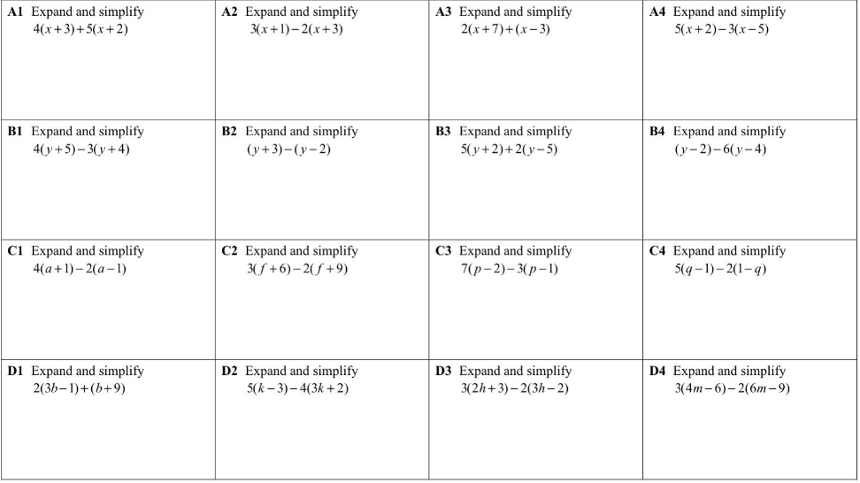

Task 2

Task 3

Task 4

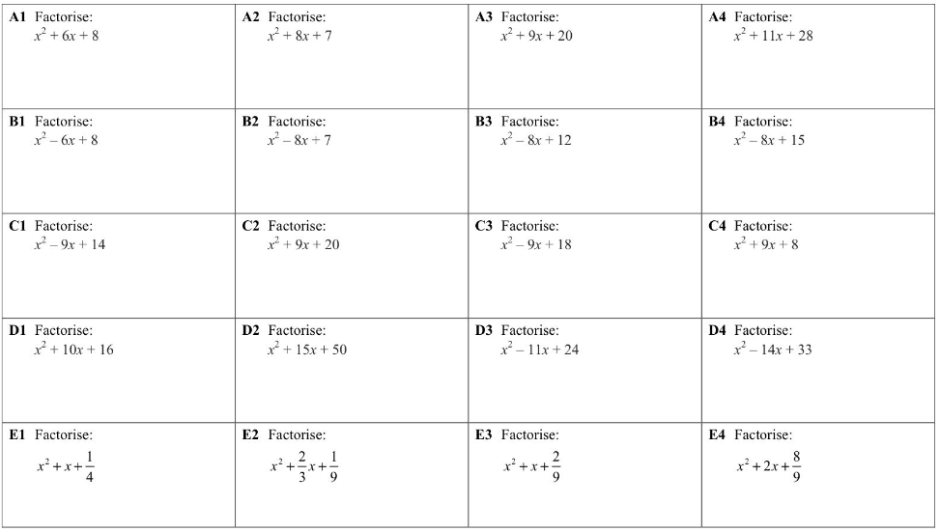

Task 5

Task 6

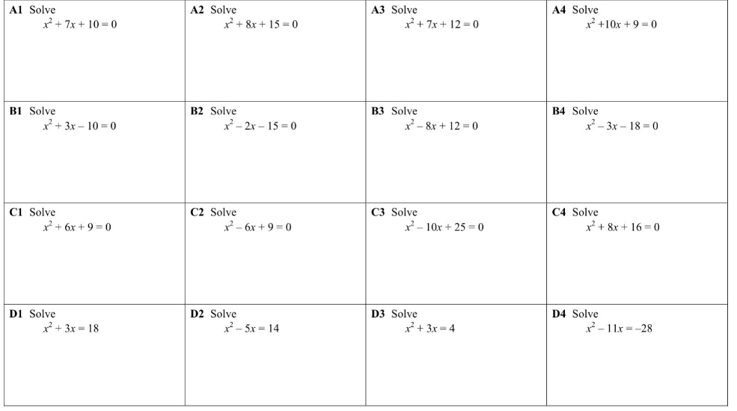

Task 7

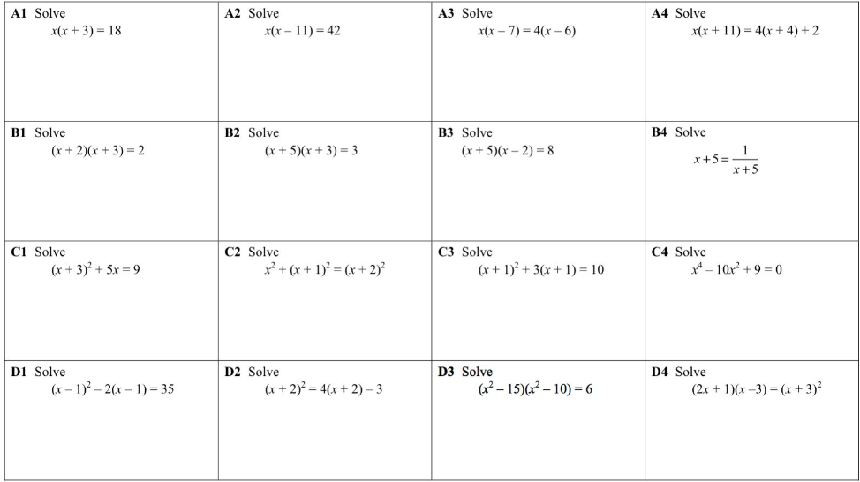

MATHS(3)

PCD

Task 1

Task 2

Task 3

Task 4

Task 5

Task 6

Task 7

SCIENCE

Year 10 Distance time graphs Revisit

Distance time graphs revisit:

A distance-time graph can be used to see when an object is stationary or travelling at a constant speed.
The steeper the slope, the faster the speed. The gradient (slope) of a distance-time graph shows the speed. This is because of the equation for speed:
Speed = distance ÷ time

If the distance-time graph is a straight line then the object is moving at a constant velocity. A steeper gradient on a straight line means a faster constant velocity.
An upwards curve means that the object is accelerating and a curve that’s levelling off shows an object is decelerating.
A flat line shows an object is stationary as its not travelling any distance. A line with a negative gradient shows that the object is travelling back in the reverse direction.

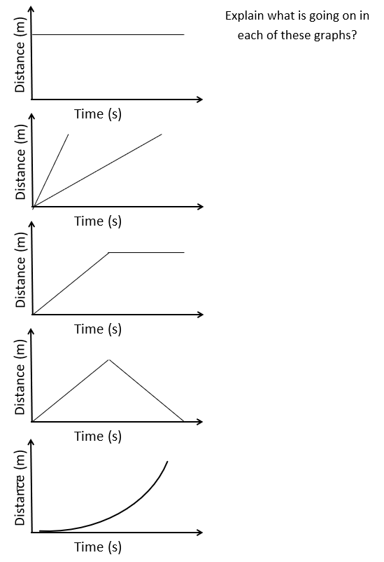
Questions on distance time graphs

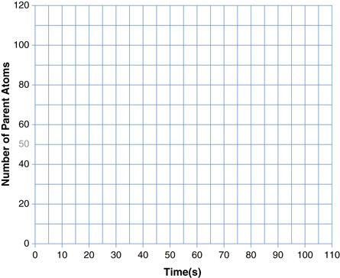
What is the speed?
Distance (m)
Distance (m)
Distance (m)

What is the speed?

What is the speed?

Year 10 Velocity time graphs

Year 10 Velocity time graphs - Notes
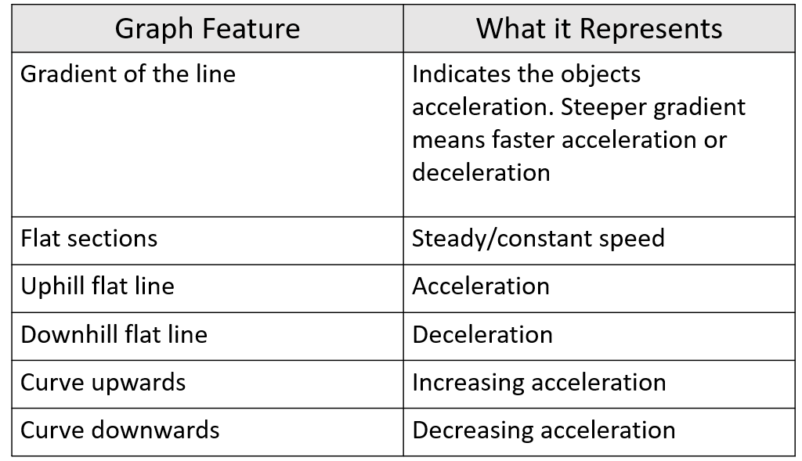
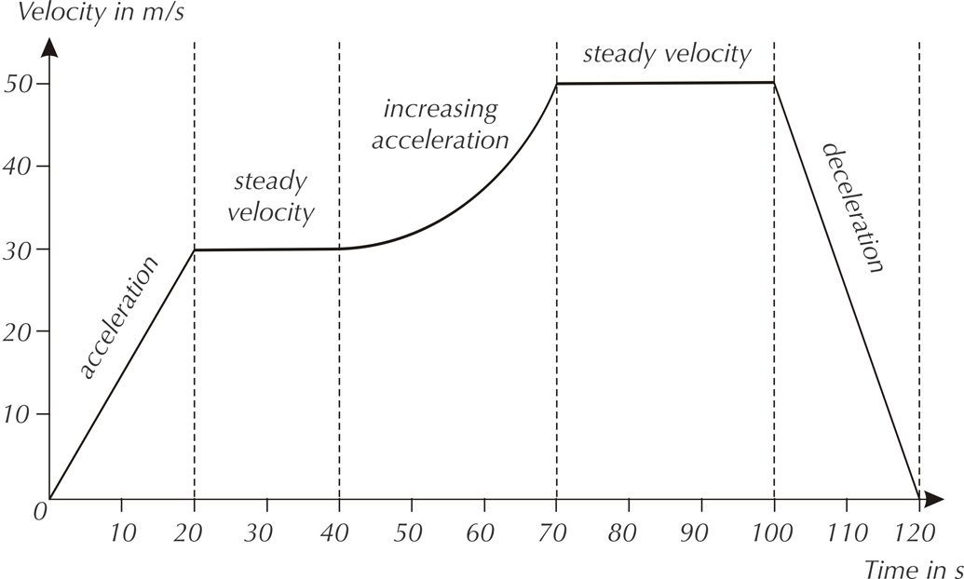

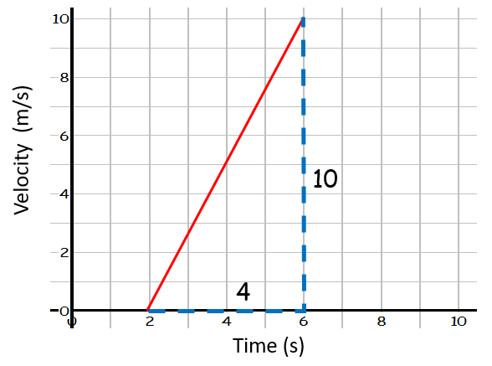
Worked Example 1)
- Find the acceleration of the object.
a = Δv ÷ t
= 10 ÷ 4
= 2.5 m/s²
- Find the distance travelled by the object.
Distance travelled = area under line
= area of triangle
= ½ b × h = ½ 4 × 10 = 20 m

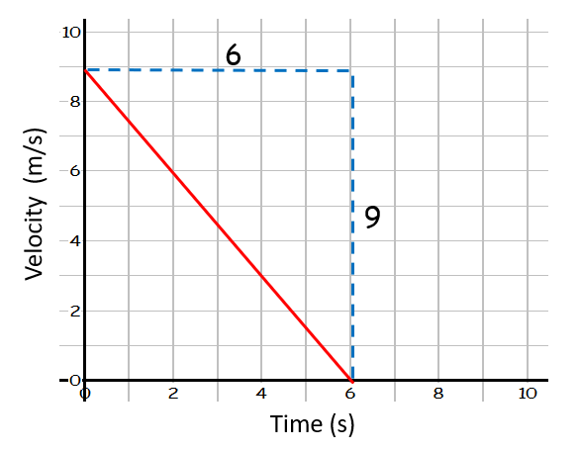
Worked Example 2)
- Find the acceleration of the object.
a = Δv ÷ t
= -9 ÷ 6
= -1.5 m/s²
- Find the distance travelled by the object.
Distance travelled = area under line
= area of triangle
= ½ b × h = ½ 6 × 9 = 27 m

Worked example 3)
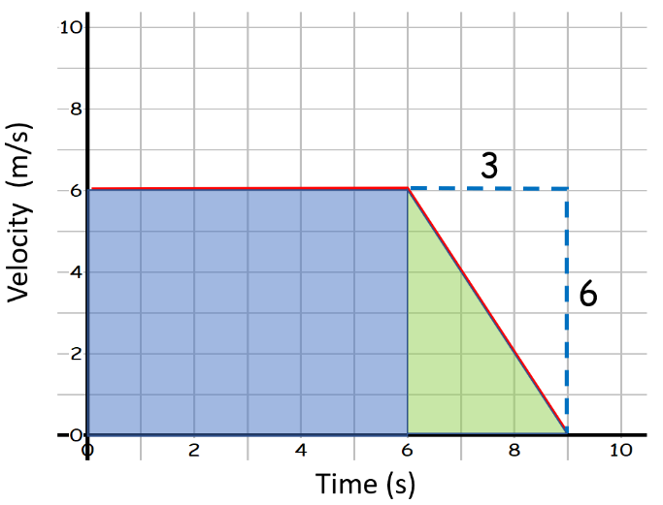
Find the distance travelled by the object.

Distance travelled = area under line
= area of square (in blue) + area of triangle (in green)
= (6 × 6) + (½ 6 × 3) = 45 m

Year 10 Velocity-time graphs- Tasks

Part A: Write what each graph shows: constant velocity, stationary, positive constant acceleration, negative constant acceleration, increasing acceleration or decreasing acceleration.

Graph a) shows ___________________. Graph d) shows __________________.
Graph b) shows ___________________. Graph e) shows __________________.
Graph c) shows ___________________. Graph f) shows __________________.

Part B: Calculate:
1) The acceleration for each of the graphs below (using the gradient).
2) The distance travelled for each of the graphs below (using the area under the graph).

- Acceleration for:
Graph a) ___________________. Graph d) __________________.
Graph b) ___________________. Graph e) __________________.
Graph c) ___________________. Graph f) __________________.
- Distance travelled for:
Graph a) ___________________. Graph d) __________________.
Graph b) ___________________. Graph e) __________________.
Graph c) ___________________. Graph f) __________________.

Graph plotting
Part C: Plot the velocity-time graph below:
Label where:
-The object is accelerating.
-The object is travelling at a constant speed.
-The object is decelerating.
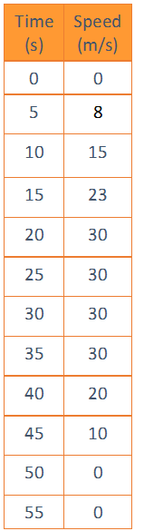
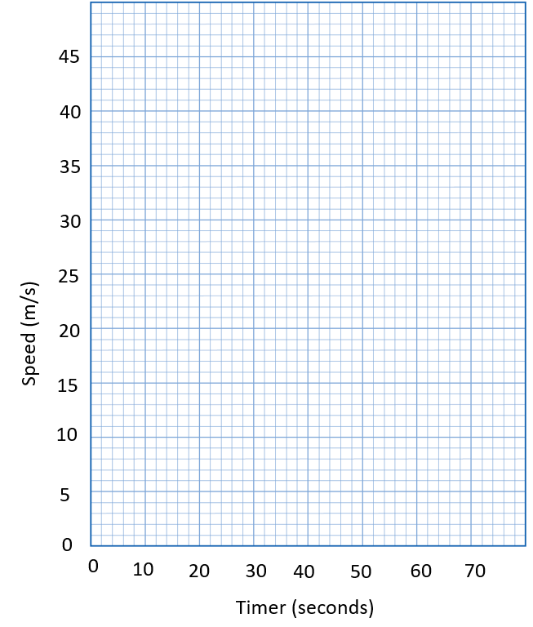
-The object is stationary.

Part D: Questions on velocity-time graphs:
Q1.A high-speed train accelerates at a constant rate in a straight line.
The velocity of the train increases from 30 m/s to 42 m/s in 60 seconds.
(a) (i) Calculate the change in the velocity of the train.
______________________________________________________________
Change in velocity = _______________ m/s
(1)
(ii) Use the equation in the box to calculate the acceleration of the train.
Show clearly how you work out your answer and give the unit.
Choose the unit from the list below.

m/s | m/s² | N/kg | Nm
______________________________________________________________
______________________________________________________________
Acceleration = _________________________
(2)
(b) Which one of the graphs, A, B or C, shows how the velocity of the train changes as it accelerates? Write your answer, A, B or C, in the box.

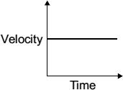  A | 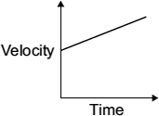  B | 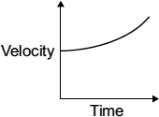  C
Graph
(1)
(Total 4 marks)
Q2.Figure 1 shows the velocity-time graph for a car driven along a straight road.
Figure 1
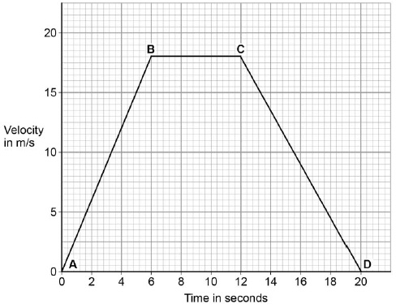
(a) From B to C the car is moving at a constant velocity.
Complete the sentence.
Choose the answer from the box.

equal to | greater than | less than
From B to C the forward driving force is _________________________ the
backward resistive force.
(1)
(b) From C to D the car is slowing down.
What word is used to describe the motion of an object that is slowing down?
___________________________________________________________________
(1)

(c) Between A and B the car is accelerating.
Calculate the acceleration of the car between A and B.
Use the equation:
___________________________________________________________________
___________________________________________________________________
___________________________________________________________________
Acceleration = ____________________ m/s²
(2)

Q3. The graph below shows the speed of a runner during an indoor 60 metres race.

a) Calculate the acceleration of the runner during the first four seconds.
b) How far does the runner travel during the first four seconds?
c) How long does the runner take to decelerate after the end of the race?
d) What is the total distance travelled by the runner?

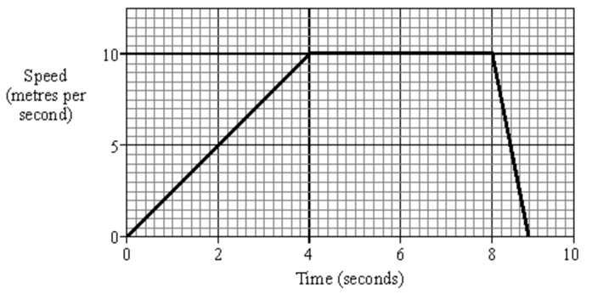

Extension Questions

- Figure 1 shows the velocity–time graph for a car when it accelerated from rest at constant acceleration.

0
2
4
6
8
10
0
5
10
15
20
25
30
Time in seconds
Velocity in
m/s
Figure 1

- How can you tell from the graph that the acceleration is constant?

- Calculate the acceleration of the car.

- Show that the car travelled a distance of 135 m in 30 s.

- Figure 2 shows the velocity–time graph for a car before and while its brakes were applied.
0
2
4
6
8
10
12
14
0
5
10
15
20
25
30
Time in seconds
Velocity in
m/s
Figure 2

- i) How long did the car travel at constant velocity for?

ii) Show that it travelled a distance of 240 m in this time.

- i) How long did the car decelerate for?

ii) How far did it travel in this time?

iii) Calculate the deceleration of the car.

- The velocity of a car on a straight test track was measured and recorded. The table below shows the measurements for the first minute after it started from rest.
Time (in s) | 0 | 10 | 20 | 30 | 40 | 50 | 60
Velocity (in m/s) | 0 | 5 | 10 | 15 | 20 | 25 | 30
- Use the data above to plot a velocity–time graph for the car.
- Calculate the acceleration of the car.

- i) What is represented by the area under the line of the graph?

ii) Use your graph to find the distance travelled by the car in 60 s from the start.

