Y10 WORK BOOKLET
(F)

Name: _________

SCIENCE

REMINDERS - COMBINED SCIENCE TRILOGY TOPICS and REQUIRED PRACTICALS
Paper 1 |  | Paper 2
Biology | Cell Biology  - Microscopy  - Osmosis | Biology | Homeostasis  6. Reaction times
 | Organisation  - Food tests  - Effect of pH on enzymes |  | Inheritance
 | Infection |  | Ecology  7. Distribution – Sampling techniques
Bioenergetics
- Photosynthesis
Chemistry | Atomic Structure | Chemistry | Rate and extent of chemical change  11. Rates of reactions
 | Structures and Bonding |  | Organic Chemistry
 | Quantitative Chemistry |  | Chemical analysis  12. Chromatography
 | Chemical changes  8. Making Salts  9. Electrolysis |  | Chemistry of the atmosphere
 | Energy changes  10. Temperature changes |  | Using resources  13. analysis and purification of water
Physics | Energy  14. Specific Heat Capacity | Physics | Forces  18. Hookes Law  19. Acceleration
 | Electricity  15. Resistance of a wire / of resistors in series and parallel  16. I-V characteristics |  | Waves  20. Waves in water and solids  21. Surfaces and radiation
 | Particle model of matter  17. Density |  | Magnets and electromagnets
 | Atomic Structure

PART 1 – CONTENT
ORGANISATION - ENZYMES

On the diagram below, label the enzyme, the substrate and the active site
+

In your own words write a description of what ‘denatured’ means
________________________________________________________________________________________________________________________________________________________________________________________________________________________________________________________________________________________

EXAMPLE QUESTION

LINKS TO DIGESTION
Add labels to the diagram below…
pancreas large intestine anus oesophagus
mouth appendix stomach small intestine

Define digestion here
________________________________________________________________________________________________________________________________________________________________________________________________________________________________________________________________________________________
Name the 3 main nutrients and next to each one write the name of the enzyme that breaks it down
- _______________ ___________________
- _______________ ___________________
- _______________ ___________________

Label on the diagram below where each enzyme is produced
Use the code P for protease, L for lipase and C for carbohydrase

What are the main nutrients broken down into?
NUTRIENT | BROKEN DOWN INTO
CARBOHYDRATE
PROTEIN
FATS

Label the diagrams using the information in the table you have just completed
BREAK DOWN OF CARBOHYDRATES (STARCH IS A CARBOHYDRATE REMEMBER)
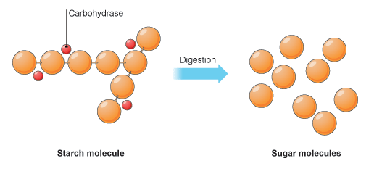

BREAK DOWN OF PROTEINS
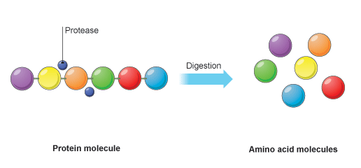
BREAK DOWN OF FATS
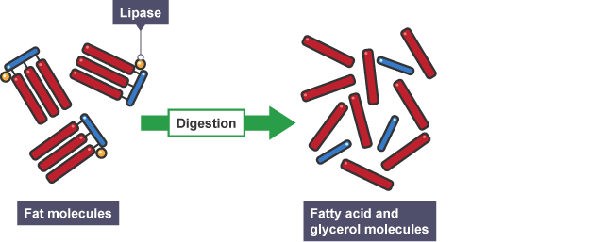
LET’S PRACTICE
TASK 1
Bile is produced in the liver, stored in the gall bladder, then released into the small intestine.

Explain how bile affects the digestion of food in the small intestine (2 marks).
______________________________________________________________________________________________________________________________________________________________________________________________________________________________________________________________________________________________________________________________________________________________

LET’S PRACTICE
TASK 2
Name the acid in the stomach and describe its function (2 marks)
______________________________________________________________________________________________________________________________________________________________________________________________________________________________________________________________________________________________________________________________________________________________

OPTIONAL - ORGANISATION – HARD LEARNING – PART 1 - FOUNDATION
- Name the theory that explains enzyme action
- What substrate does amylase work on?
- And what does it break it down into?
- What substrate does protease work on?
- And what does it break it down into?
- What substrate does lipase work on?
- And what does it break it down into
- Define digestion

- Where is bile made?
- Where is bile stored?
- Explain the two functions of bile

PART 2 – REQUIRED PRACTICALS
Organisation Required Practicals

- Effect of pH on enzyme action

Key terms

Amylase - Enzyme that controls the breakdown of starch in the digestive system

Denature - When an enzyme’s active site loses its shape meaning it can work no longer

Enzymes - Molecules that act as catalysts in biological systems

Aim- To determine the rate of the amylase activity at different pHs.
The different pHs to be investigated will be produced using buffer solutions. Buffer solutions produce a particular pH, and will maintain it if other substances are added.
In this practical you will:
- use the enzyme amylase to break down starch at different pH values
- measure the pH of different solutions
- use a water bath to keep reacting solutions at a constant temperature
- use a continuous sampling technique
- use iodine solution as an indicator of the breakdown of starch into sugars.
Equipment
- 10 test tubes
- a test tube rack
- a water bath
- a thermometer
- a spotting tile
- a 5 cm³ measuring cylinder
- Pipettes
- a glass rod
- a stop clock
- starch solution
- amylase solution
- iodine solution
- labelled buffered solutions at a range of pH values
Using the information provided, complete the method to investigate the effect of pH on enzyme activity. You should then self-assess this using the method at the end of the workbook.

1. Place 1 drop of ………….. into a well on the …………….. ……….
2. Place labelled test tubes containing the buffered ……. solutions,
amylase solution and starch solutions in to the water bath. Allow
them to reach 35°C
3. Add 2cm3 of one of the buffered solutions to a test tube
4. Add 2cm3 of ………………
5. Start the ………. ……….
6. Mix using a glass rod
7. After 30 seconds, remove a drop of the mixture and add to the
first well of the spotting tile.
8. Repeat, adding a drop of the mixture every …….. seconds
9. Continue until the iodine solution and the amylase/buffer/starch
mixture stays orange
When the iodine no longer changes colour it means that there is no starch present
10. Repeat with solutions of different pH (2,4,6,8)

Questions
- Identify the following from the investigations:
- Independent variable: ________________________________________________

- Dependent variable: _________________________________________________

- Control variables x2: _________________________________________________ ________________________________________________

- Why was the water bath set at 35 °C?
________________________________________________________________________________________________________________________________
Exam questions
Q1. Figure 1 shows the human digestive system.
Figure 1
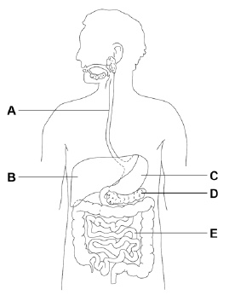
(a) Which organ in Figure 1 produces acid? Tick one box.

A |  | B |  | C |  | D |  | E
(1)
(b) Which organ in Figure 1 produces bile? Tick one box.

A |  | B |  | C |  | D |  | E
(1)
(c) Where in Figure 1 are digested foods absorbed into the blood? Tick one box.

A |  | B |  | C |  | D |  | E
(1)

(d) Food molecules such as proteins cannot be absorbed unless they are digested. Give one reason why.
___________________________________________________________________
__________________________________________________________________
(1)

A scientist investigated the effect of pH on the activity of two protease enzymes. Figure 2 shows the results.
Figure 2
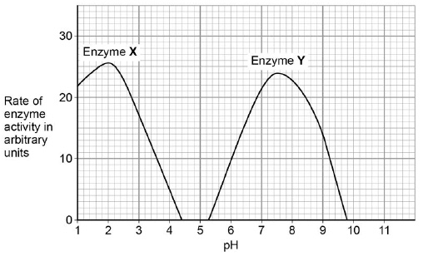
(e) What is the optimum pH for enzyme Y?
pH ____________________ (1)

(f) Where in the digestive system might the two protease enzymes be produced? Tick one box.

Enzyme X | Enzyme Y
Mouth | Stomach
Pancreas | Mouth
Small intestine | Pancreas
Stomach | Small intestine
(1)

Figure 3 shows a model of an enzyme molecule.
Figure 3
(g) Which substrate fits the enzyme molecule in Figure 3?
Tick one box.
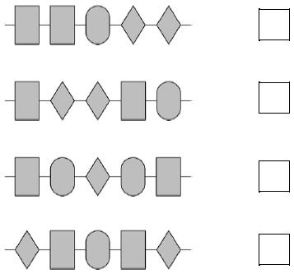
(1)
(h) The enzyme and substrate diagrams are used as a model for a theory of enzyme action. What is the name of this theory? Tick one box.
Evolution
Lock and key
Natural selection
Protein synthesis
(1)

- Food tests

Aim- To use reagents (chemical indicators) to test for the presence of carbohydrates, lipids and proteins in a range of foods.

The Benedict’s test for sugars

Equipment

• food sample
• a test tube
• Benedict’s solution
• traditional water bath to include Bunsen burner use
• thermometer
• pipettes.

How would you prepare a food sample? (This will be the same for ALL the food tests)
_________________________________________________________________________________
__________________________________________________________________________________________________________________________________________________________________
_________________________________________________________________________________
How would you test for sugars?
_________________________________________________________________________________
__________________________________________________________________________________________________________________________________________________________________
What colour would you see if there was a positive test (sugar is present)?
_________________________________________________________________________________

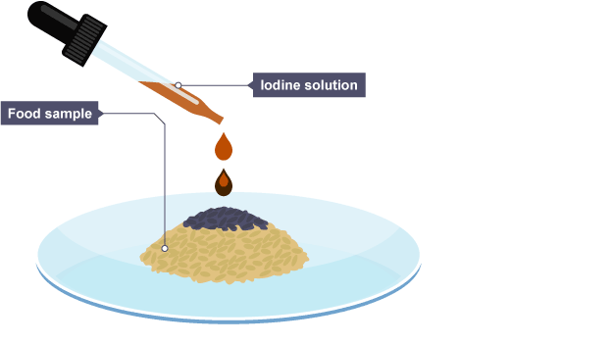
The iodine test for starch
Equipment
• food sample
• a test tube
• iodine solution
• pipettes.

How would you test for starch?
_________________________________________________________________________________
__________________________________________________________________________________________________________________________________________________________________
__________________________________________________________________________________________________________________________________________________________________
_________________________________________________________________________________
_________________________________________________________________________________
_________________________________________________________________________________

What colour would you see if there was a positive test (starch is present)?
_________________________________________________________________________________

Test for lipids
Apparatus
• food sample
• a test tube
• ethanol
• distilled water.
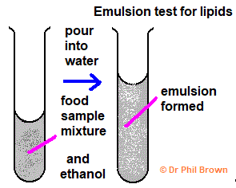
How would you test a food item for lipids (fats).
_________________________________________________________________________________
__________________________________________________________________________________________________________________________________________________________________
_________________________________________________________________________________
_________________________________________________________________________________
_________________________________________________________________________________
__________________________________________________________________________________________________________________________________________________________________

What colour would you see if there was a positive test (lipids are present)?
_________________________________________________________________________________

Test for protein
Equipment
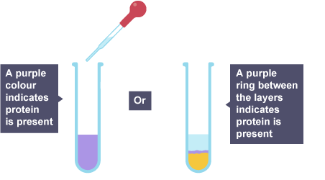
- a test tube
- a 10 cm³ measuring cylinder
- biuret solution A and biuret solution B

How would you test a food item for protein.
_________________________________________________________________________________
__________________________________________________________________________________________________________________________________________________________________
_________________________________________________________________________________
_________________________________________________________________________________

What colour would you see if there was a positive test (protein is present)?
_________________________________________________________________________________

Exam Questions
Q1. An athlete decides to try a new type of protein drink after he exercises.
(a) The athlete tests the protein drink to check it contains protein.
Which solution is used to test for protein in the drink?
Tick one box.

Benedict’s
Biuret
Iodine
Universal indicator
(1)
(b) What colour will the solution turn to if there is protein in the drink?
Tick one box.

Blue-black
Purple
Red
Yellow
(1)

(c) Why is a high protein diet useful to an athlete? Tick one box.

Provides amino acids to make new muscle.
Provides fatty acids to produce urea.
Provides glucose for energy.
Provides lactic acid for anaerobic respiration.
(1)
When the athlete drinks the protein drink the substances are digested.
The products of digestion are absorbed into the bloodstream.
Absorption happens in the small intestine.
Figure 2 shows a section of the small intestine.
Figure 2
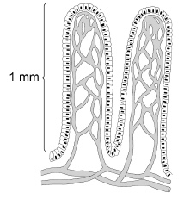
(d) How is the small intestine in Figure 2 adapted to absorb the products of digestion quickly?
Tick two boxes.

It has a large surface area.
It has a long diffusion pathway.
It has a thin surface.
The concentration inside the small intestine is low.
It has a poor blood supply.
(2)
Q2. Some students tested a red cabbage leaf for starch.
This is the method used.
1. Boil the leaf in ethanol.
2. Rinse the leaf in water.
3. Add the reagent to test the leaf for starch.
(a) Which reagent is used to test the boiled leaf for starch?
Tick one box.

Benedict’s solution
Biuret solution
Iodine solution
Sodium chloride solution
(1)
(b) What colour will be seen if the test for starch is positive?
Tick one box.

Blue-black
Pale pink
Orange
Red
(1)

MATHS (2)

PCD

Task 1

Task 2

Task 3

Task 4

Task 5

Task 6

Task 7

Task 8

Task 9

MATHS (3)

PCD

Task 1

Task 2

Task 3

Task 4

Task 5

Task 6

Task 7

Task 8

Task 9

ENGLISH

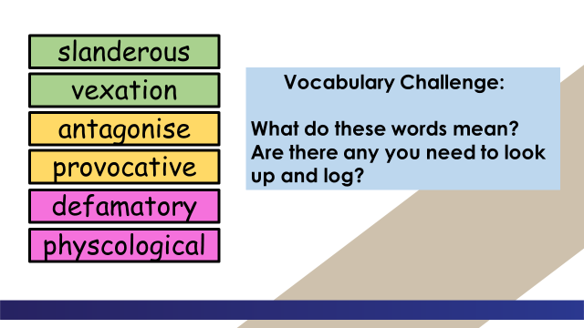

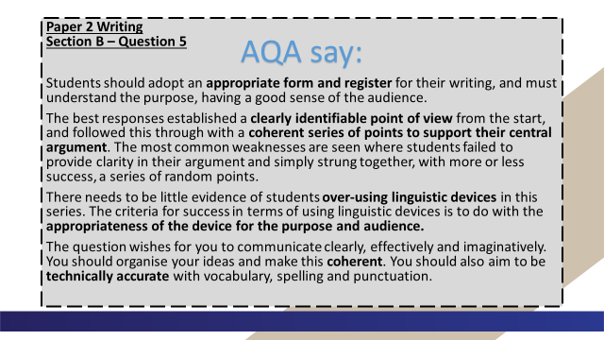

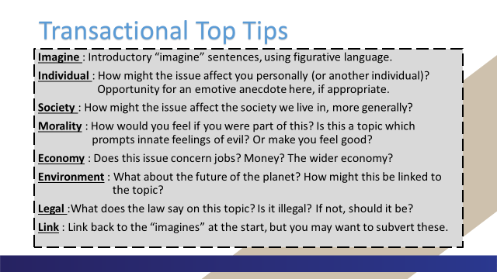

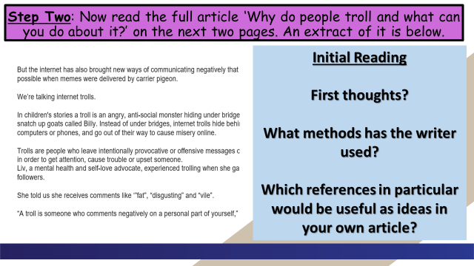

Why do people troll and what can you do about it?

The internet has given us many wonderful things: instant messaging, movies on demand, online gaming, BBC Bitesize…
But the internet has also brought new ways of communicating negatively that weren’t possible when memes were delivered by carrier pigeon.
We’re talking internet trolls.
In children's stories a troll is an angry, anti-social monster hiding under bridges ready to snatch up goats called Billy. Instead of under bridges, internet trolls hide behind their computers or phones, and go out of their way to cause misery online.
Trolls are people who leave intentionally provocative or offensive messages on the internet in order to get attention, cause trouble or upset someone.
Liv, a mental health and self-love advocate, experienced trolling when she gained more followers.
She told us she receives comments like ‘”fat”, “disgusting” and “vile”.
“A troll is someone who comments negatively on a personal part of yourself,” she said.

What types of trolls are there?
Imran Ahmed, CEO of the Centre for Countering Digital Hate (CCDH), an NGO that has produced a practical guide for public figures dealing with trolls called Don’t Feed the Trolls, said there are two main types of troll.
The first type of troll targets public figures with large social media followings in the hope that they respond.
The trolls then have their hateful messages re-broadcast to a wider audience when the target of their trolling, or their followers, respond.
The other type of trolls are people who exhibit a psychological trait known as 'negative social potency' - this means they enjoy causing harm to others:
“These trolls get pleasure from upsetting those they target with abuse, so if their victim responds it only encourages them to continue,” said Imran.

Why do people troll?
There are many reasons why people might troll online, and it’s different from one troll to the next.
Dr Mark Griffiths, Professor of Behavioural Addiction at Nottingham Trent University said: “Most people troll others for either revenge, for attention seeking, for boredom, and for personal amusement.”
“They want to lash out at people who are being successful, who are happy, who are enjoying their life because they can’t,” said Liv.
“I think people troll because they’re insecure in themselves, they want to get a kick out of being negative towards someone else,” said Fatima.

What should you do if you’re being trolled?
We asked CCDH for some advice on what to do if you are being trolled:
- Don’t respond
- Block the trolls’ accounts
- Don’t post online that you’re being targeted
- Take some time out from social media
- If the abuse you receive makes you feel at threat or is otherwise unlawful - report it to the social media platform and the police.

Can anyone be tempted to troll?
You might be tempted to troll. You might see something or someone online that you don’t like and be tempted to send an unkind message.
Rosie’s advice to stop yourself becoming a troll is to put yourself in the person’s shoes and that’ll make you think twice about what you post.
Imran also warned that anonymity is not necessarily a protection:
“People have been excluded from school or university, lost their jobs, their friends, and even been jailed for sending abuse online. Not only is it a horrible thing to do, you are risking your own future by engaging in trolling,” he said.

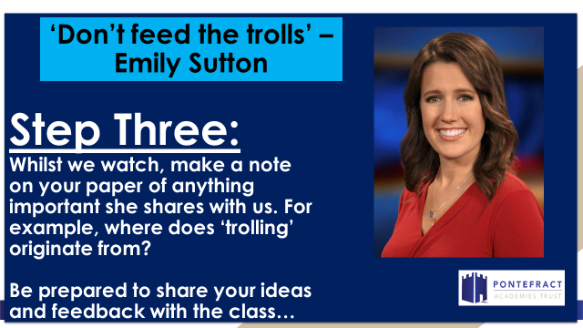

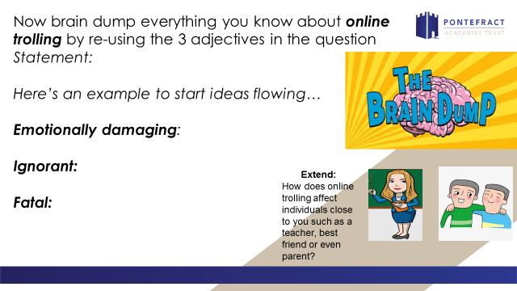

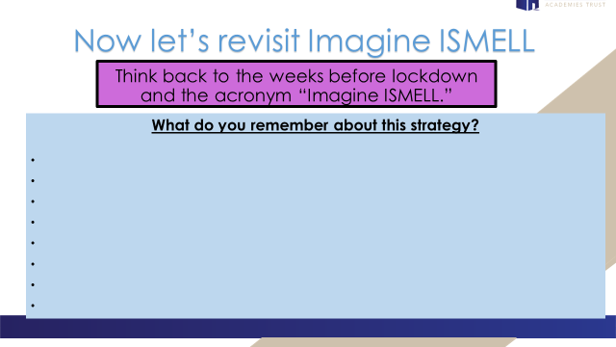

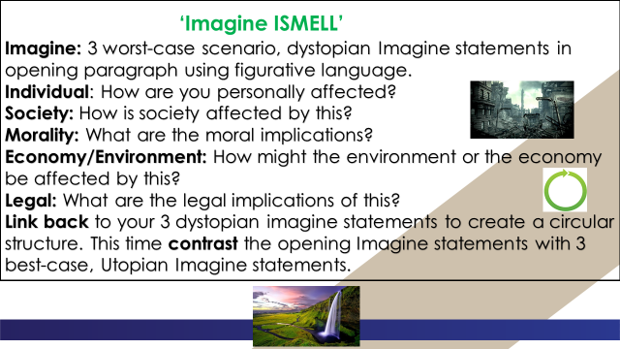

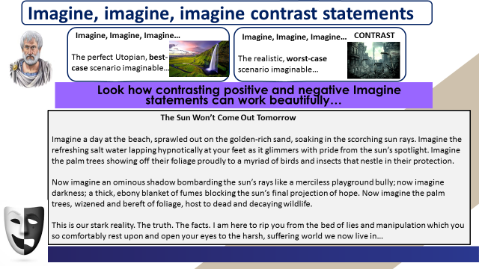

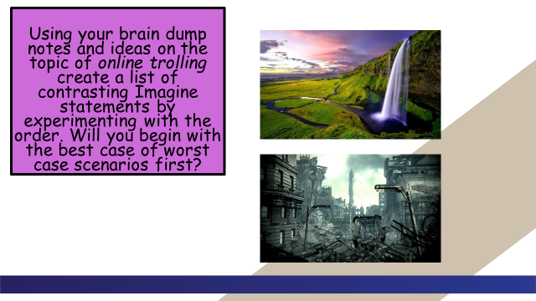

Now let’s revisit your main task.

______________________________________________________________________________________________________________________________________________________________________________________________________________________________________________________________________________________________________________________________________________________________________________________________________________________________________________________________________________________________________________________________________________________________________________________________________________________________________________________________________________________________________________________________________________________________________________________________________________________________________________________________________________________________________________________________________________________________________________________________________________________________________________________________________________________________________________________________________________________________________________________________________________________________________________________________________________________________________________________________________________________________________________________________________________________________________________________________________________________________________________________________
____________________________________________________________________________________________________________________________________________________________________________________________________________________________________________________________________________________________________________________________________________________________________________________________________________________________________________________________________________________________________________________________________________________________________________________________________________________________________________________________________________________________________________________________________________________________________________________________________________________________________________________________________________________________________________________________________________________________________________________________________________________________________________________________________________________________________________________________________________________________________________________________________________________________________________________________________________________________________________________________________________________________________________________________________________________________________________________________________________________________________________________________________________________________________________________________________________________________________________________________________________________________________________________________________________________________________________________________________________________________________________________________________________________________________________________________________________________________________________________________________________________________________________________________________________________________________________________________________________________________________________________________________________________________________________

