Y10 WORK BOOKLET
(H)

Name: _________

ENGLISH

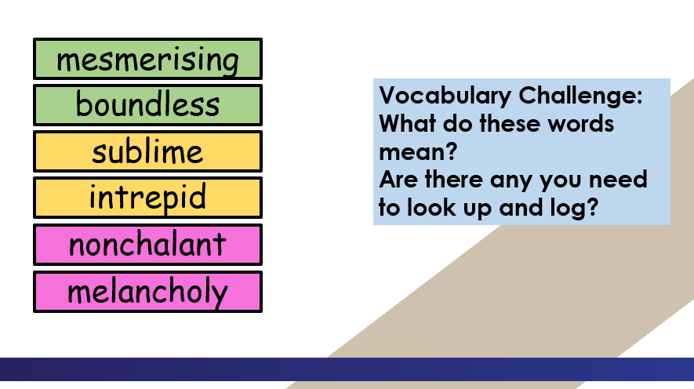

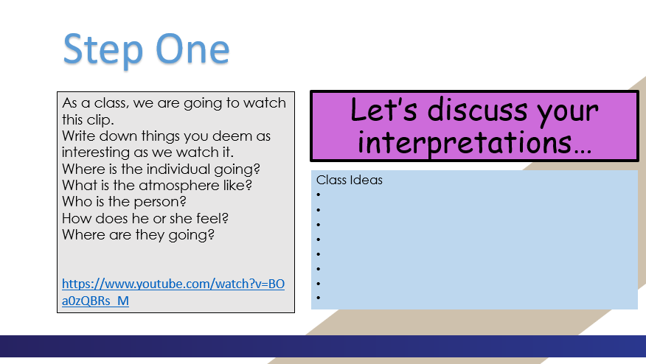

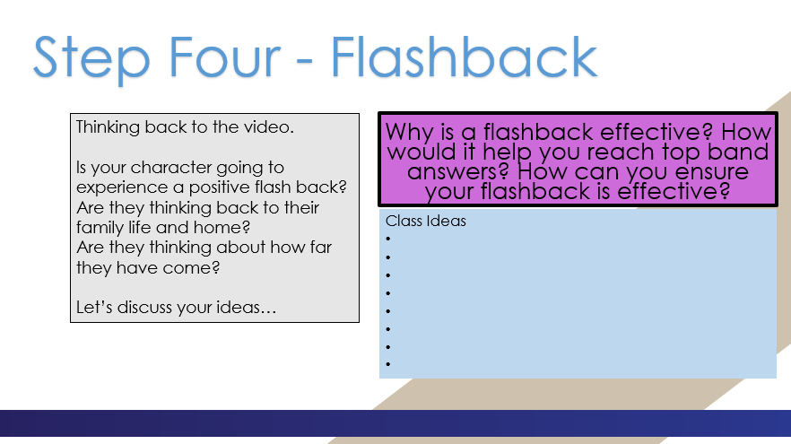

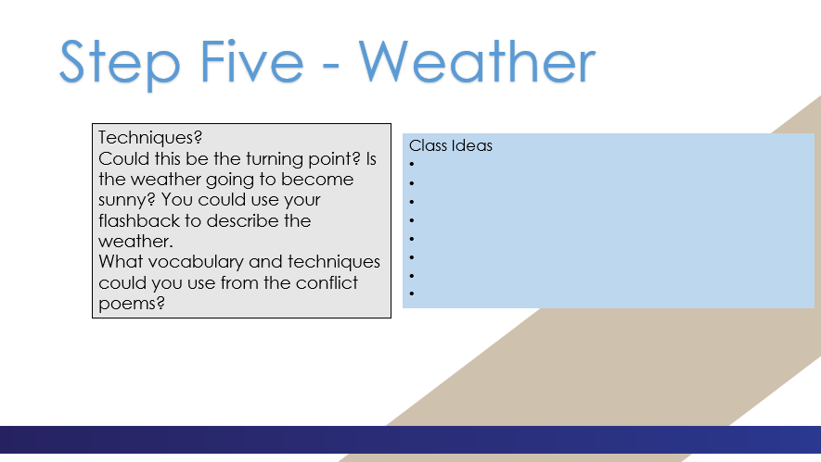

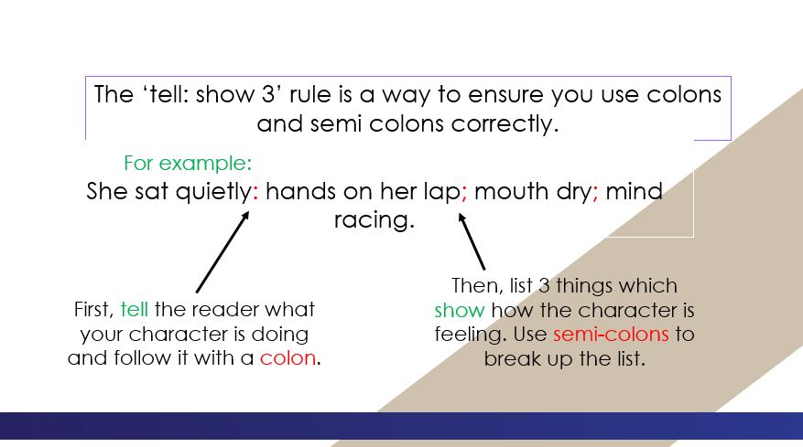

______________________________________________________________________________________________________________________________________________________________________________________________________________________________________________________________________________________________________________________________________________________________________________________________________________________________________________________________________________________________________________________________________________________________________________________________________________________________________________________________________________________________________________________________________________________________________________________________________________________________________________________________________________________________________________________________________________________________________________________________________________________________________________________________________________________________________________________________________________________________________________________________________________________________________________________________________________________________________________________________________________________________________________________________________________________________________________________________________________________________________________________________
____________________________________________________________________________________________________________________________________________________________________________________________________________________________________________________________________________________________________________________________________________________________________________________________________________________________________________________________________________________________________________________________________________________________________________________________________________________________________________________________________________________________________________________________________________________________________________________________________________________________________________________________________________________________________________________________________________________________________________________________________________________________________________________________________________________________________________________________________________________________________________________________________________________________________________________________________________________________________________________________________________________________________________________________________________________________________________________________________________________________________________________________________________________________________________________________________________________________________________________________________________________________________________________________________________________________________________________________________________________________________________________________________________________________________________________________________________________________________________________________________________________________________________________________________________________________________________________________________________________________________________________________________________________________________________

MATHS(1)

PCD

Task 1

Task 2

Task 3

Questions

Task 4

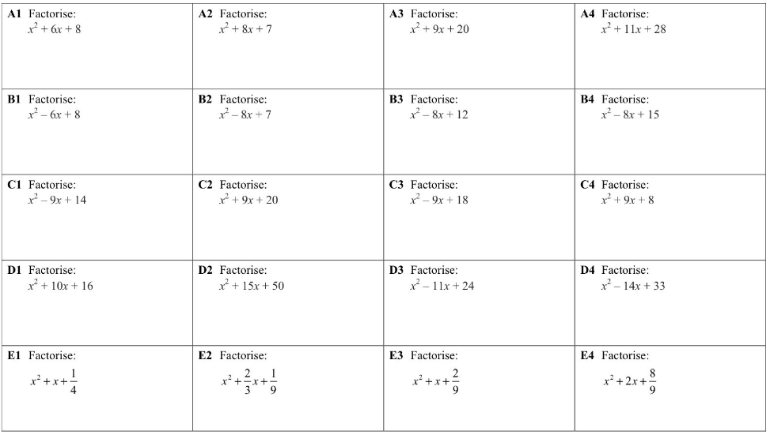

Task 5

Task 6

Task 7

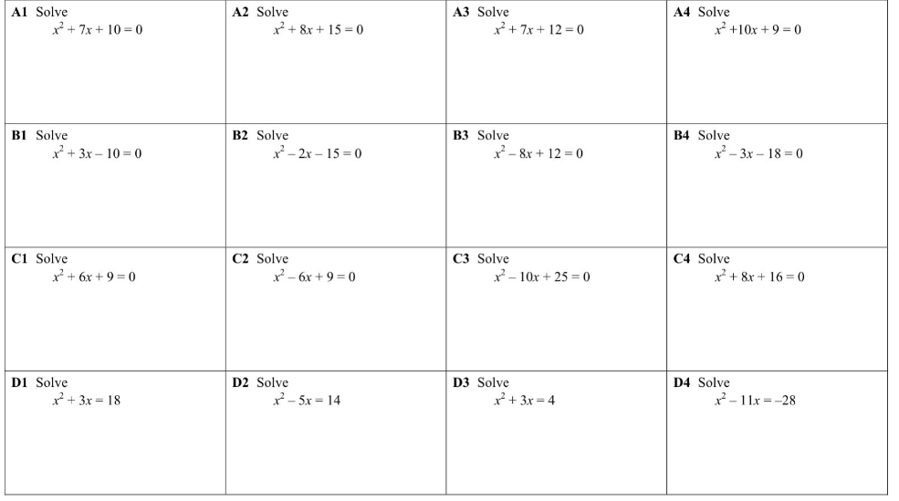

Task 8

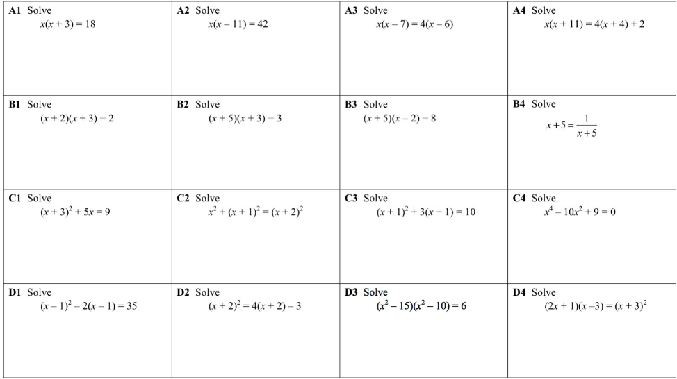

Task 9

Task 10

MATHS(2)

PCD

Task 1

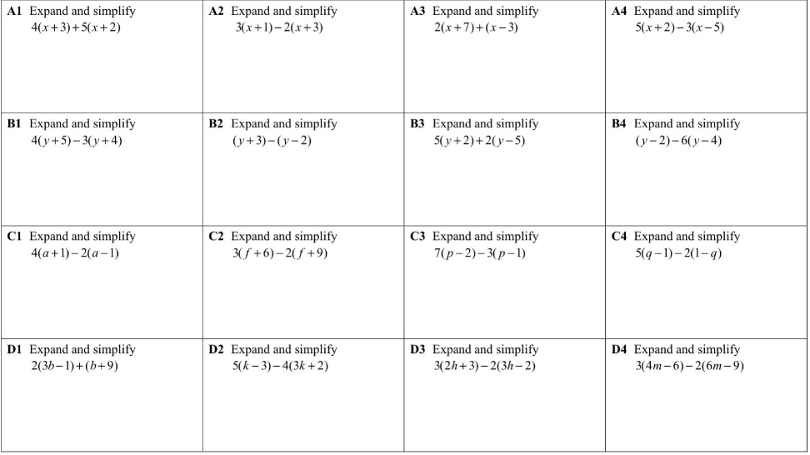

Task 2

Task 3

Task 4

Task 5

Task 6

Task 7

SCIENCE

Year 10 Distance time graphs Revisit

Year 10 Distance time graphs Revisit

Distance time graphs revisit:

A distance-time graph can be used to see when an object is stationary or travelling at a constant speed.
The steeper the slope, the faster the speed. The gradient (slope) of a distance-time graph shows the speed. This is because of the equation for speed:
v = s ÷ t

If the distance-time graph is a straight line then the object is moving at a constant velocity. A steeper gradient on a straight line means a faster constant velocity.
An upwards curve means that the object is accelerating and a curve that’s levelling off shows an object is decelerating.
A flat line shows an object is stationary as its not travelling any distance. A line with a negative gradient shows that the object is travelling back in the reverse direction.

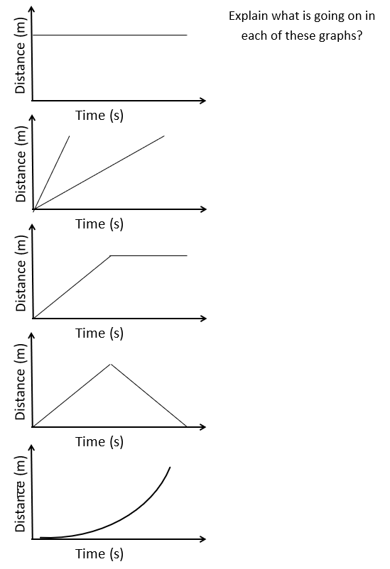
Questions on distance time graphs
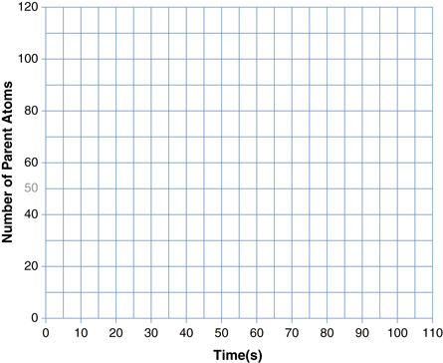
What is the speed?
Distance (m)
Distance (m)
Distance (m)

What is the speed?

What is the speed?

Year 10 Velocity time graphs

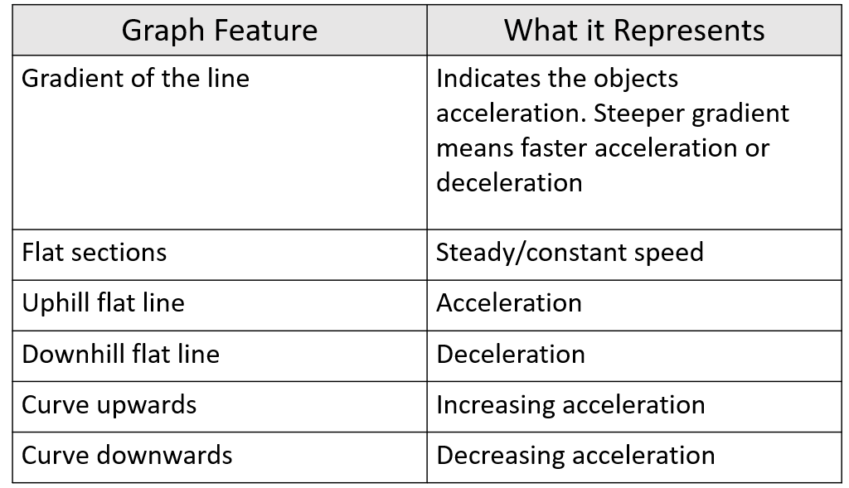

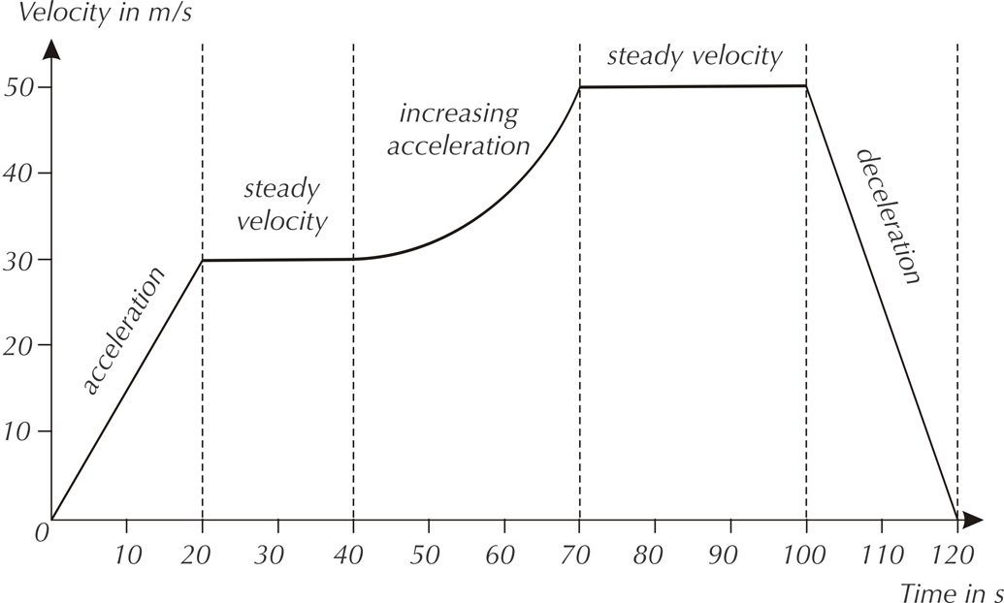

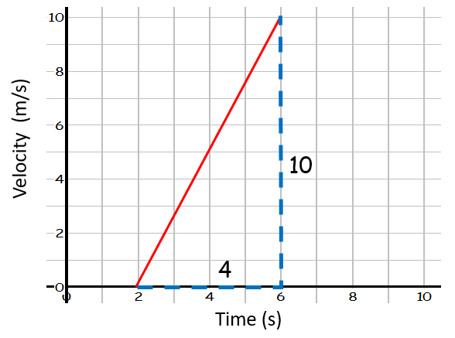
Worked Example 1)
- Find the acceleration of the object.
a = Δv ÷ t
= 10 ÷ 4
= 2.5 m/s²
- Find the distance travelled by the object.
Distance travelled = area under line
= area of triangle
= ½ b × h = ½ 4 × 10 = 20 m

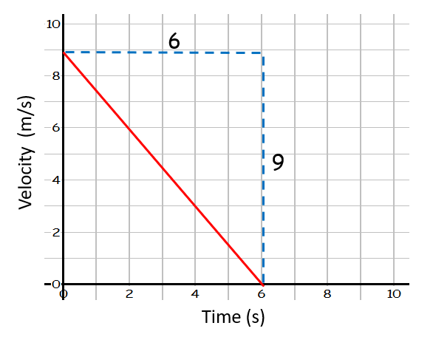
Worked Example 2)
- Find the acceleration of the object.
a = Δv ÷ t
= -9 ÷ 6
= -1.5 m/s²
- Find the distance travelled by the object.
Distance travelled = area under line
= area of triangle
= ½ b × h = ½ 6 × 9 = 27 m

Worked example 3)
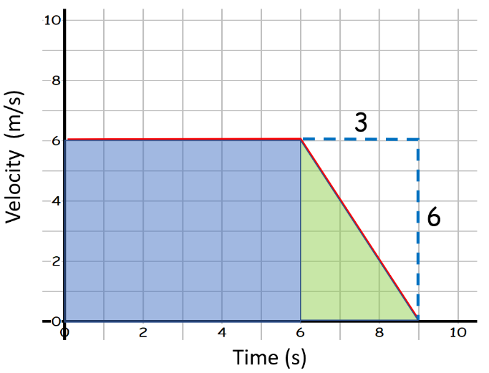
Find the distance travelled by the object.

Distance travelled = area under line
= area of square (in blue) + area of triangle (in green)
= (6 × 6) + (½ 6 × 3) = 45 m

Part A: Write what each graph shows: constant velocity, stationary, positive constant acceleration, negative constant acceleration, increasing acceleration or decreasing acceleration.

Graph a) shows ___________________. Graph d) shows __________________.
Graph b) shows ___________________. Graph e) shows __________________.
Graph c) shows ___________________. Graph f) shows __________________.

Part B: Calculate:
1) The acceleration for each of the graphs below (using the gradient).
2) The distance travelled for each of the graphs below (using the area under the graph).
- Acceleration for:
Graph a) ___________________. Graph d) __________________.
Graph b) ___________________. Graph e) __________________.
Graph c) ___________________. Graph f) __________________.

- Distance travelled for:
Graph a) ___________________. Graph d) __________________.
Graph b) ___________________. Graph e) __________________.
Graph c) ___________________. Graph f) __________________.

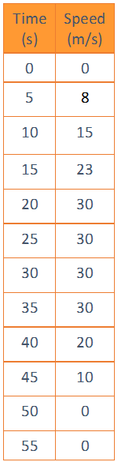
Graph plotting
Part C: Plot the velocity-time graph above:
Label where:
-The object is accelerating.
-The object is travelling at a constant speed.
-The object is decelerating.
-The object is stationary.

Part D - Exam style questions
Q1. The graph below shows the speed of a runner during an indoor 60 metres race.

a) Calculate the acceleration of the runner during the first four seconds.
b) How far does the runner travel during the first four seconds?
c) How long does the runner take to decelerate after the end of the race?
d) What is the total distance travelled by the runner?
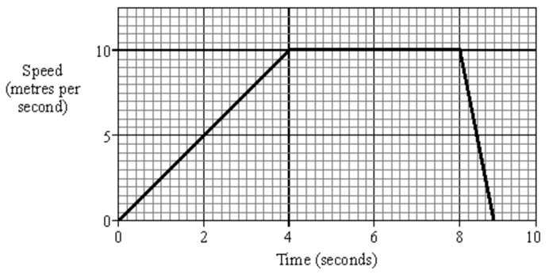

Q2.(a) Draw one line from each velocity−time graph to the statement describing the motion shown by the graph.
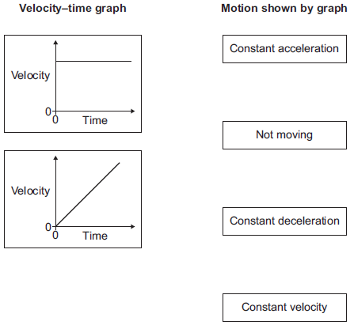
(2)

(b) Use the correct answer from the box to complete the sentence.

energy | momentum | speed
The velocity of an object includes both the _________________________ of the object and the direction the object is moving.
(1)
(c) At the start of a race, a horse accelerates from a velocity of 0 m/s to a velocity of 9 m/s in 4 seconds.
(i) Calculate the acceleration of the horse.
______________________________________________________________
______________________________________________________________
Acceleration = ______________________ m/s²
(2)
(ii) When the horse accelerates, what, if anything, happens to the air resistance acting against the horse?
Tick () one box.

The air resistance decreases
The air resistance is constant
The air resistance increases
(1)

(d) A horse and a pony walk across a field at the same constant speed.
The horse has 4000 joules of kinetic energy.
The pony is half the mass of the horse.
What is the kinetic energy of the pony?
Draw a ring around the correct answer

2000 J | 4000 J | 8000 J
Give a reason for your answer.
___________________________________________________________________
___________________________________________________________________
(2)
(Total 8 marks)
Q4.The graph shows changes in the velocity of a racing car.
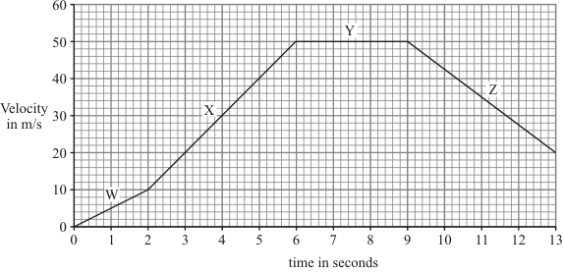
(a) Describe the motion of the racing car during:
(i) the period labelled W; ____________________________________________
______________________________________________________________
(1)
(ii) the period labelled Y. ____________________________________________
______________________________________________________________
(1)
(b) Calculate the acceleration of the racing car during the period labelled X.
Show clearly how you work out your answer and give the unit.
___________________________________________________________________
___________________________________________________________________
___________________________________________________________________
___________________________________________________________________
___________________________________________________________________
___________________________________________________________________
___________________________________________________________________
___________________________________________________________________
Acceleration = _______________________
(4)
(Total 6 marks)

Extension tasks:

To extend your knowledge and understanding of acceleration, velocity and distance.
1 The figure below shows the velocity–time graph for a vehicle when it was accelerating.
0
5
10
15
20
25
30
0
5
10
15
20
Time in seconds
Velocity in
m/s

a) Calculate the acceleration of the vehicle.

b) i) Show that the distance travelled by the vehicle in 20 s was 300 m.

ii) Calculate the average velocity of the vehicle .

2 The figure below shows the velocity–time graph for a car moving along a straight road.
0
5
10
15
20
25
0
5
10
15
20
25
30
35
40
time in seconds
velocity in
m/s
a) Describe the motion of the car for the period shown by the graph.

b) Calculate the acceleration of the car when it accelerated.

c) Calculate the distance travelled by the car:
i) in the first 10 s.

ii) when it accelerated.

iii) in the last 10 s.

d) Show that the average velocity of the car for the period shown was 15 m/s.

3 The following measurements were made when a ball rolled down a slope after being released from rest at the top.
Distance travelled from the start  (in metres) | 0 | 0.50 | 1.00 | 1.50 | 2.00 | 2.50
Time from release  (in seconds) | 0 | 0.50 | 0.70 | 0.85 | 1.00 | 1.10
a) Plot a distance–time graph using the measurements above.
b) i) What does your graph tell you about the velocity of the ball?

ii) Calculate the average velocity of the ball on the slope.

iii) Assuming the velocity at the end was twice the average velocity, calculate the acceleration of the ball.

