Y10 WORK BOOKLET
(H)

Name: _________

SCIENCE

REMINDERS - COMBINED SCIENCE TRILOGY TOPICS and REQUIRED PRACTICALS
Paper 1 |  | Paper 2
Biology | Cell Biology  - Microscopy  - Osmosis | Biology | Homeostasis  6. Reaction times
 | Organisation  - Food tests  - Effect of pH on enzymes |  | Inheritance
 | Infection |  | Ecology  7. Distribution – Sampling techniques
Bioenergetics
- Photosynthesis
Chemistry | Atomic Structure | Chemistry | Rate and extent of chemical change  11. Rates of reactions
 | Structures and Bonding |  | Organic Chemistry
 | Quantitative Chemistry |  | Chemical analysis  12. Chromatography
 | Chemical changes  8. Making Salts  9. Electrolysis |  | Chemistry of the atmosphere
 | Energy changes  10. Temperature changes |  | Using resources  13. analysis and purification of water
Physics | Energy  14. Specific Heat Capacity | Physics | Forces  18. Hookes Law  19. Acceleration
 | Electricity  15. Resistance of a wire / of resistors in series and parallel  16. I-V characteristics |  | Waves  20. Waves in water and solids  21. Surfaces and radiation
 | Particle model of matter  17. Density |  | Magnets and electromagnets

PART 1 – CONTENT
ORGANISATION - ENZYMES

On the diagram below, label the enzyme, the substrate and the active site
+

In your own words write a description of what ‘denatured’ means
________________________________________________________________________________________________________________________________________________________________________________________________________________________________________________________________________________________________________

EXAMPLE QUESTION

LINKS TO DIGESTION
Add labels to the diagram below…
pancreas large intestine anus oesophagus
mouth appendix stomach small intestine

Define digestion here
________________________________________________________________________________________________________________________________________________________________________________________________________________________________________________________________________________________

Name the 3 main nutrients and next to each one write the name of the enzyme that breaks it down
- _______________ ___________________
- _______________ ___________________
- _______________ ___________________

Label on the diagram below where each enzyme is produced
Use the code P for protease, L for lipase and C for carbohydrase
What are the main nutrients broken down into?
NUTRIENT | BROKEN DOWN INTO
CARBOHYDRATE
PROTEIN
FATS

Label the diagrams using the information in the table you have just completed
BREAK DOWN OF CARBOHYDRATES (STARCH IS A CARBOHYDRATE REMEMBER)
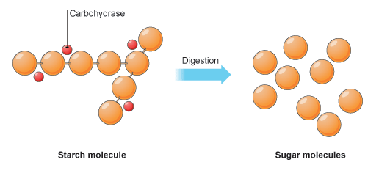

BREAK DOWN OF PROTEINS
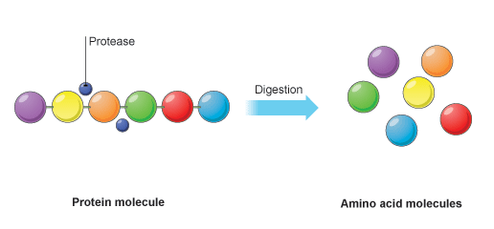
BREAK DOWN OF FATS
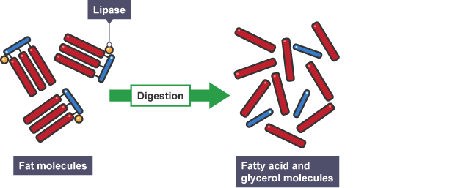
LET’S PRACTICE
TASK 1
Bile is produced in the liver, stored in the gall bladder, then released into the small intestine.

Explain how bile affects the digestion of food in the small intestine (2 marks).
______________________________________________________________________________________________________________________________________________________________________________________________________________________________________________________________________________________________________________________________________________________________

LET’S PRACTICE
TASK 2
Name the acid in the stomach and describe its function (2 marks)
______________________________________________________________________________________________________________________________________________________________________________________________________________________________________________________________________________________________________________________________________________________________

OPTIONAL EXTRA - ORGANISATION – HARD LEARNING
- Name the theory that explains enzyme action
- What substrate does amylase work on?
- And what does it break it down into?
- What substrate does protease work on?
- And what does it break it down into?
- What substrate does lipase work on?
- And what does it break it down into
- Define digestion

- Where is bile made?
- Where is bile stored?
- Explain the two functions of bile

FURTHER EXAM PRACTICE QUESTIONS – ENZYMES – STANDARD AND HIGH DEMAND – (MARK SCHEME PROVIDED AFTER EACH QUESTION)
QUESTION 1

The diagram shows part of the human digestive system.

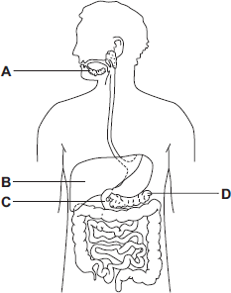

(a) Name the parts of the digestive system labelled A, B, C and D.

A ________________________________________

B ________________________________________

C ________________________________________

D ________________________________________

(4)

(b) A student has eaten a steak for dinner. The steak contains protein and fat.

(i) Describe how the protein is digested.

______________________________________________________________

_____________________________________________________________

_____________________________________________________________

_____________________________________________________________

_____________________________________________________________

(3)

(ii) Explain two ways in which bile helps the body to digest fat.

______________________________________________________________

_____________________________________________________________

_____________________________________________________________

_____________________________________________________________

_____________________________________________________________

_____________________________________________________________

(4)

(c) A group of students investigated the action of salivary amylase.
The students:

• collected a sample of salivary amylase

• put a different pH solution and 5 cm³ of a food substance in each of 6 test tubes

• added 1 cm³ of salivary amylase to each of the 6 test tubes

• recorded the amylase activity after 10 minutes.

The results are shown in the table.

pH | 7 | 6 | 5 | 4 | 3 | 2
Amylase activity in  arbitrary units | 12 | 10 | 3 | 0 | 0 | 0

(i) Name the food substance that amylase breaks down.

_____________________________________________________________

(1)

(ii) Suggest what happens to the breakdown of this substance when food reaches the stomach. Use information from the table to help you to answer this question.

_____________________________________________________________

_____________________________________________________________

_____________________________________________________________

_____________________________________________________________

__________________________________________________________(3)

(Total 15 marks)
MARK SCHEME FOR QUESTION 1

(a) A − saliva(ry) gland

1

B − liver

1

C − duodenum

ignore small intestine

1

D − pancreas

accept phonetic spellings

1

(b) (i) any three from:

• chewing / muscle contraction / mechanical digestion

allow churning

• protease enzymes

allow pepsin / trypsin

• in stomach / small intestine / duodenum / from pancreas

• (break down protein) into amino acids

allow (poly)peptides

3

(ii) neutralises acid pH / makes conditions alkaline

1

so lipase can work

1

emulsifies fat

1

to give large(r) surface area for lipase / enzyme action

1

(c) (i) starch

ignore carbohydrate

1

(ii) breakdown stops

allow slows down

1

because stomach produces / contains acid / has low pH

1

and amylase cannot work in acid / low pH

accept amylase is denatured / changes shape

1

[15]

QUESTION 2

A patient has a disease. The disease damages his pancreas.

A doctor prescribes a course of treatment for the patient:
‘Take one capsule with each meal.’

Each capsule contains hundreds of small, dry beads.

The beads are made of enzymes. The pancreas normally produces these enzymes.

The outer coating of the capsule is made of lipid.

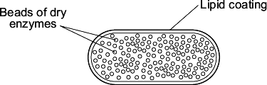

(a) One enzyme in the beads is lipase.

In a healthy person, lipase is made in the pancreas.

Name two other enzymes made in the pancreas of a healthy person.

1. _________________________________________________________________

2. ______________________________________________________________(2)

(b) The lipid coating on the capsule makes sure that the enzymes are not released until the capsule reaches the small intestine. Explain how. ____________________________________________________________

__________________________________________________________________

__________________________________________________________________

__________________________________________________________________

_______________________________________________________________(2)

(c) The lipase in the beads does not digest the lipid coating around the capsule. Suggest why.

___________________________________________________________________

______________________________________________________________(1)

(Total 5 marks)

MARK SCHEME FOR QUESTION 2

(a) protease

allow trypsin / peptidase

do not allow pepsin

1

carbohydrase / amylase

do not allow sucrase / maltase / lactase

1

(b) no lipase produced / found

1

in stomach / mouth / before small intestine
OR
accept lipase only produced / found (1)
in small intestine / pancreas (1)

if no other mark is awarded lipid is not broken down in the stomach or lipid is digested in small intestine gains 1 mark

1

(c) enzymes only work in solution / when dissolved
or
because enzyme / lipase / it is dry

allow enzymes only work in presence of water or enzymes do not work when dry

ignore other physical conditions

1

QUESTION 3

Enzymes are used in biological detergents.

(a) Name the type of enzyme that digests stains containing fats.

______________________________________________________________(1)

(b) A new detergent is marketed as being ‘environmentally-friendly’.

Scientists compared the performance of this new detergent with an existing detergent.

They measured the time taken by the two detergents to remove a fat stain at different temperatures.

The graph shows their results.

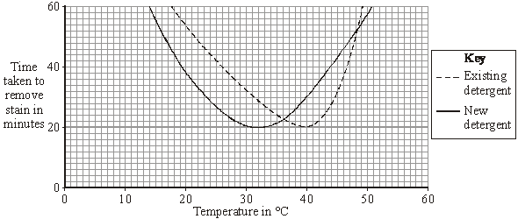

(i) Describe the effect of increasing the temperature on the time taken by the existing detergent to remove the stain.

_____________________________________________________________

_____________________________________________________________

______________________________________________________________

_____________________________________________________________

(2)

(ii) The new detergent works at a lower temperature than the existing one.

Is the new detergent likely to be more ‘environmentally-friendly’ than the existing detergent?

Draw a ring around your answer. Yes / No

Explain the reason for your answer.

_____________________________________________________________

_____________________________________________________________

______________________________________________________________

_______________________________________________(2)

(c) Neither detergent works well at 60 °C.

Explain why.

__________________________________________________________________

__________________________________________________________________

__________________________________________________________________

(2)

(Total 7 marks)

MARK SCHEME FOR QUESTION 3

(a) lipase

allow phonetic spelling

allow lipidase

1

(b) (i) fall then rise owtte eg down then up

allow faster then slower

ignore explanations

1

minimum / least / fastest / best / optimum at 39–41(°C)

allow it falls to 40(°C)

if no other marks gained, ‘falls to an optimum’ gains 1 mark

1

(ii) (yes) there is no mark for circling ‘yes’

maximum 1 mark if No is circled

any two from:

• less heat / energy / electricity / power required /
used / wasted

ignore lower temperature

• conserves fuel supplies
or less fuel used

• less pollution from power stations
owtte

accept less global warming

or

less CO₂ / carbon emissions / greenhouse gases

or

less SO₂ / acid rain

NB only direct effects

less pollution only is not enough

2

(c) any two from: max 1 mark for reference to cell

• enzyme / lipase (accept any named enzyme)

• destroyed / denatured - allow damaged / broken down do not allow ‘killed’

• reference to (specific) shape changed

ignore detergent / it

2

[7]
PART 2 – REQUIRED PRACTICALS
Organisation Required Practicals
- Effect of pH on enzyme action

Key terms

Amylase - Enzyme that controls the breakdown of starch in the digestive system

Denature - When an enzyme’s active site loses its shape meaning it can work no longer

Enzymes - Molecules that act as catalysts in biological systems

Aim- To determine the rate of the amylase activity at different pHs.

The different pHs to be investigated will be produced using buffer solutions. Buffer solutions produce a particular pH, and will maintain it if other substances are added.
In this practical you will:
- use the enzyme amylase to break down starch at different pH values
- measure the pH of different solutions
- use a water bath to keep reacting solutions at a constant temperature
- use a continuous sampling technique
- use iodine solution as an indicator of the breakdown of starch into sugars.
Apparatus
- 10 test tubes
- a test tube rack
- a water bath
- a thermometer
- a spotting tile
- a 5 cm³ measuring cylinder
- Pipettes
- a glass rod
- a stop clock
- starch solution
- amylase solution
- iodine solution
- labelled buffered solutions at a range of pH values

Using the information provided, write a method to investigate the effect of pH on enzyme activity.

_______________________________________________________________________________________________________________________________________________________________________________________________________________________________________________________________________________________________________________________________________________________________________________________________________________________________________________________________________________________________________________________________________________________________________________________________________________________________________________________________________________________________________________________________________________________________________________________________________________________________________________________________________________________________________________________________________________________________________________________________________________________________________________________________________________________________________________________________________________________________________________________________________________________________________________________________

Questions

- Identify the following from the investigations:
- Independent variable: ______________________________________________
- Dependent variable: ______________________________________________
- Control variables x2: ______________________________________________
______________________________________________

- Why was the water bath set at 35 °C?
______________________________________________________________________________________________________________________________________________________

Exam questions
Q1. Figure 1 shows the human digestive system. Figure 1
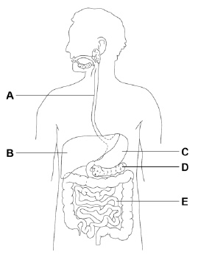
(a) Which organ in Figure 1 produces acid? Tick one box.

A |  | B |  | C |  | D |  | E
(1)
(b) Which organ in Figure 1 produces bile? Tick one box.

A |  | B |  | C |  | D |  | E
(1)
(c) Where in Figure 1 are digested foods absorbed into the blood? Tick one box.

A |  | B |  | C |  | D |  | E
(1)
(d) Food molecules such as proteins cannot be absorbed unless they are digested. Give one reason why.
__________________________________________________________________
__________________________________________________________________
(1)

A scientist investigated the effect of pH on the activity of two protease enzymes.
Figure 2 shows the results.
Figure 2
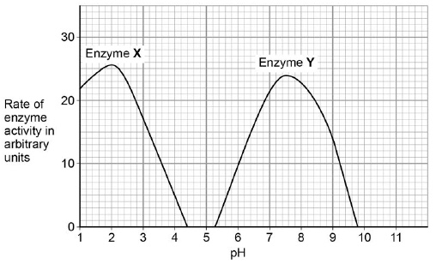
(e) What is the optimum pH for enzyme Y?
pH ____________________
(1)
(f) Where in the digestive system might the two protease enzymes be produced?
Tick one box.

Enzyme X | Enzyme Y
Mouth | Stomach
Pancreas | Mouth
Small intestine | Pancreas
Stomach | Small intestine
(1)

Figure 3 shows a model of an enzyme molecule.
Figure 3
(g) Which substrate fits the enzyme molecule in Figure 3? Tick one box.
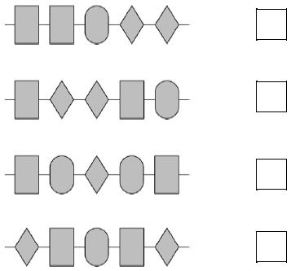
(1)
(h) The enzyme and substrate diagrams are used as a model for a theory of enzyme action.
What is the name of this theory? Tick one box.

Evolution
Lock and key
Natural selection
Protein synthesis
(1)

(i) Explain why pH affects enzyme activity.
___________________________________________________________________
__________________________________________________________________
__________________________________________________________________
__________________________________________________________________
(2)

(ii) A food contains protein. Describe, in as much detail as you can, what happens to this protein after the food is swallowed.
__________________________________________________________________
__________________________________________________________________
__________________________________________________________________
__________________________________________________________________
__________________________________________________________________
__________________________________________________________________
__________________________________________________________________
(4)

- Food tests
Key terms
Carbohydrates: food belonging to the group consisting of sugars, starch and cellulose
Lipid: fats (solids) and oils (liquids). Composed of fatty acids and glycerol
Protein: organic compound made up of amino acid molecules. Needed by the body for growth and repair
Qualitative: data that deals with descriptions

Aim
To use qualitative reagents to test for the presence of carbohydrates, lipids and proteins in a range of foods.

The Benedict’s test for sugars
Apparatus
• food sample
• a test tube
• Benedict’s solution
• traditional water bath to include Bunsen burner use
• thermometer
• pipettes.

How do you prepare a food sample? (This will be the same for ALL the food tests)
_________________________________________________________________________________
_________________________________________________________________________________
_________________________________________________________________________________
_________________________________________________________________________________
How would you test for sugars?
_________________________________________________________________________________
_________________________________________________________________________________
_________________________________________________________________________________

What colour would you see if there was a positive test (sugar is present)?
_________________________________________________________________________________

TEST FOR STARCH
Apparatus
• food sample
• a test tube
• iodine solution
• pipettes.
How would you test for starch?
_________________________________________________________________________________
_________________________________________________________________________________
_________________________________________________________________________________
_________________________________________________________________________________
_________________________________________________________________________________

What colour would you see if there was a positive test (starch is present)?
_________________________________________________________________________________

TEST FOR LIPIDS
Apparatus
• food sample
• a test tube
• ethanol
• distilled water.
How would you to test a food item for lipids (fats).
_________________________________________________________________________________
_________________________________________________________________________________
_________________________________________________________________________________

What colour would you see if there was a positive test (lipids are present)?
_________________________________________________________________________________

TEST FOR PROTEIN
Apparatus
a test tube
a 10 cm3 measuring cylinder
biuret solution A and biuret solution B

How would you test a food item for protein.
_________________________________________________________________________________
_________________________________________________________________________________
_________________________________________________________________________________
_________________________________________________________________________________
_________________________________________________________________________________
_________________________________________________________________________________
_________________________________________________________________________________
_________________________________________________________________________________

What colour would you see if there was a positive test (protein is present)?
_________________________________________________________________________________

Exam Questions
Q1. An athlete decides to try a new type of protein drink after he exercises.
(a) The athlete tests the protein drink to check it contains protein.
Which solution is used to test for protein in the drink?
Tick one box.

Benedict’s
Biuret
Iodine
Universal indicator
(1)
(b) What colour will the solution turn to if there is protein in the drink?
Tick one box.

Blue-black
Purple
Red
Yellow
(1)

Figure 1 shows the proportion of different nutrients in the protein drink.
Figure 1
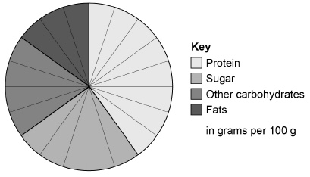

(c) What is the ratio of sugar to protein in the protein drink?

1:1 |  | 1:0:6 |  | 1:2 |  | 1:1:6
(1)
(d) Why is a high protein diet useful to an athlete?
Tick one box.

Provides amino acids to make new muscle.
Provides fatty acids to produce urea.
Provides glucose for energy.
Provides lactic acid for anaerobic respiration.
(1)

When the athlete drinks the protein drink the substances are digested.
The products of digestion are absorbed into the bloodstream.
Absorption happens in the small intestine.
Figure 2 shows a section of the small intestine.
Figure 2
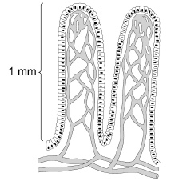

(e) How is the small intestine in Figure 2 adapted to absorb the products of digestion quickly?
Tick two boxes.

It has a large surface area.
It has a long diffusion pathway.
It has a thin surface.
The concentration inside the small intestine is low.
It has a poor blood supply.
(2)

(f) Figure 3 shows the proportion of different nutrients in four protein drinks.
Figure 3
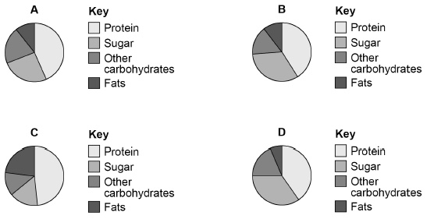
Which protein drink should an athlete with diabetes use?
Give a reason for your answer.
Drink ____________________
Reason ____________________________________________________________
____________________________________________________________
(2)
(Total 8 marks)

MATHS (1)

PCD

Task 1

Exam Questions

Task 2

Task 3

Task 4

Task 5

Task 6

Task 7

Task 8

Task 9

Task 10

MATHS (2)

PCD

Task 1

Task 2

Task 3

Task 4

Task 5

Task 6

Task 7

Task 8

Task 9

ENGLISH

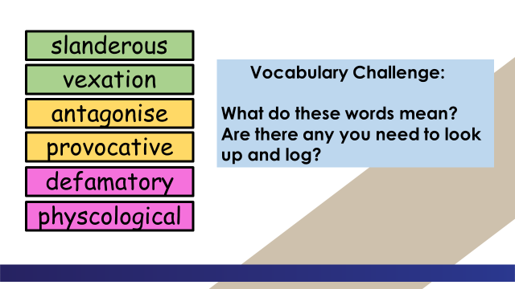

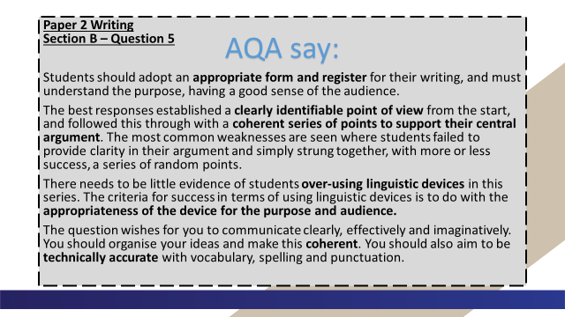

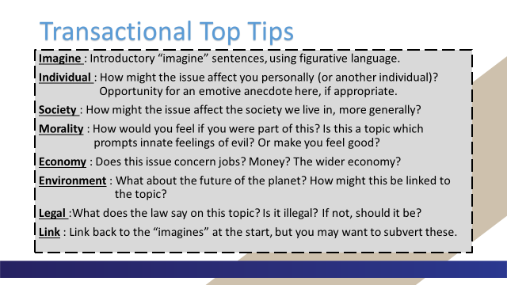

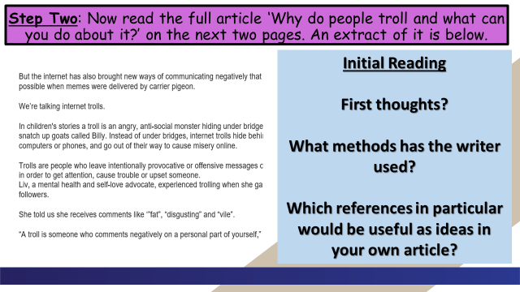

Why do people troll and what can you do about it?

The internet has given us many wonderful things: instant messaging, movies on demand, online gaming, BBC Bitesize…
But the internet has also brought new ways of communicating negatively that weren’t possible when memes were delivered by carrier pigeon.
We’re talking internet trolls.
In children's stories a troll is an angry, anti-social monster hiding under bridges ready to snatch up goats called Billy. Instead of under bridges, internet trolls hide behind their computers or phones, and go out of their way to cause misery online.
Trolls are people who leave intentionally provocative or offensive messages on the internet in order to get attention, cause trouble or upset someone.
Liv, a mental health and self-love advocate, experienced trolling when she gained more followers.
She told us she receives comments like ‘”fat”, “disgusting” and “vile”.
“A troll is someone who comments negatively on a personal part of yourself,” she said.

What types of trolls are there?
Imran Ahmed, CEO of the Centre for Countering Digital Hate (CCDH), an NGO that has produced a practical guide for public figures dealing with trolls called Don’t Feed the Trolls, said there are two main types of troll.
The first type of troll targets public figures with large social media followings in the hope that they respond.
The trolls then have their hateful messages re-broadcast to a wider audience when the target of their trolling, or their followers, respond.
The other type of trolls are people who exhibit a psychological trait known as 'negative social potency' - this means they enjoy causing harm to others:
“These trolls get pleasure from upsetting those they target with abuse, so if their victim responds it only encourages them to continue,” said Imran.

Why do people troll?
There are many reasons why people might troll online, and it’s different from one troll to the next.
Dr Mark Griffiths, Professor of Behavioural Addiction at Nottingham Trent University said: “Most people troll others for either revenge, for attention seeking, for boredom, and for personal amusement.”
“They want to lash out at people who are being successful, who are happy, who are enjoying their life because they can’t,” said Liv.
“I think people troll because they’re insecure in themselves, they want to get a kick out of being negative towards someone else,” said Fatima.

What should you do if you’re being trolled?
We asked CCDH for some advice on what to do if you are being trolled:
- Don’t respond
- Block the trolls’ accounts
- Don’t post online that you’re being targeted
- Take some time out from social media
- If the abuse you receive makes you feel at threat or is otherwise unlawful - report it to the social media platform and the police.

Can anyone be tempted to troll?
You might be tempted to troll. You might see something or someone online that you don’t like and be tempted to send an unkind message.
Rosie’s advice to stop yourself becoming a troll is to put yourself in the person’s shoes and that’ll make you think twice about what you post.
Imran also warned that anonymity is not necessarily a protection:
“People have been excluded from school or university, lost their jobs, their friends, and even been jailed for sending abuse online. Not only is it a horrible thing to do, you are risking your own future by engaging in trolling,” he said.

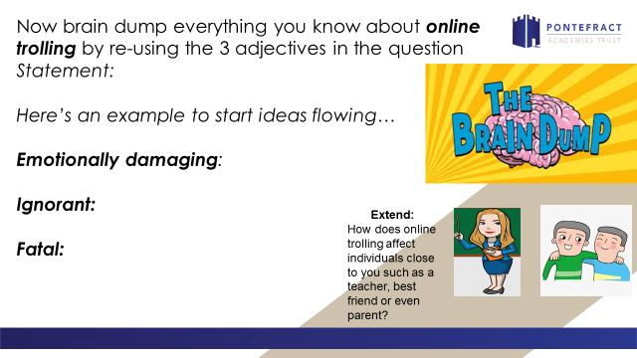

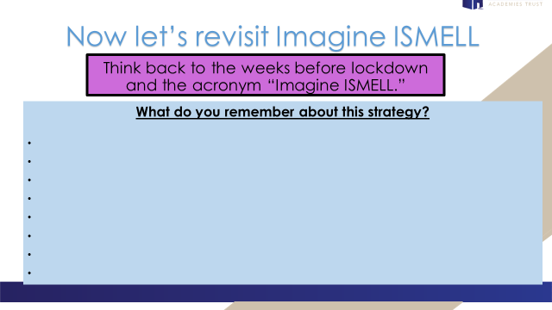

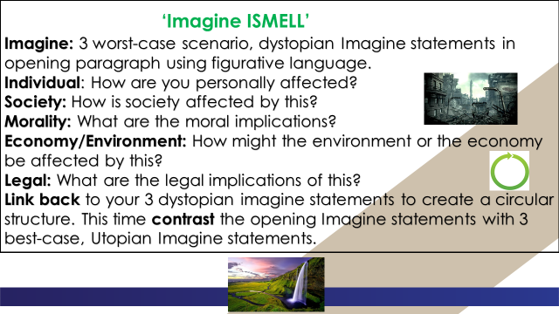

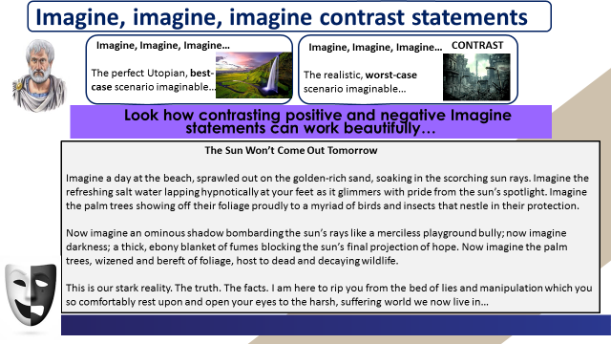

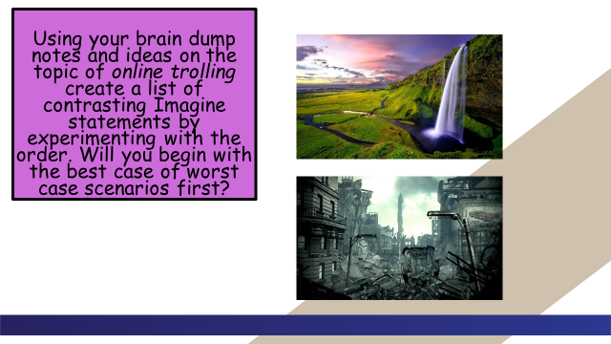

Now let’s revisit your main task.

______________________________________________________________________________________________________________________________________________________________________________________________________________________________________________________________________________________________________________________________________________________________________________________________________________________________________________________________________________________________________________________________________________________________________________________________________________________________________________________________________________________________________________________________________________________________________________________________________________________________________________________________________________________________________________________________________________________________________________________________________________________________________________________________________________________________________________________________________________________________________________________________________________________________________________________________________________________________________________________________________________________________________________________________________________________________________________________________________________________________________________________________
____________________________________________________________________________________________________________________________________________________________________________________________________________________________________________________________________________________________________________________________________________________________________________________________________________________________________________________________________________________________________________________________________________________________________________________________________________________________________________________________________________________________________________________________________________________________________________________________________________________________________________________________________________________________________________________________________________________________________________________________________________________________________________________________________________________________________________________________________________________________________________________________________________________________________________________________________________________________________________________________________________________________________________________________________________________________________________________________________________________________________________________________________________________________________________________________________________________________________________________________________________________________________________________________________________________________________________________________________________________________________________________________________________________________________________________________________________________________________________________________________________________________________________________________________________________________________________________________________________________________________________________________________________________________________________

