ART: Optional Summer Project

What is the Optional Summer Project?
Key Stage 3
Take a tour in person or virtually to some of the art galleries and museums in the local area. Be inspired by what you see, take photographs, produce a drawing or create a sketchbook/scrap book of your travels/activities. The joy and interest is sometimes in the places and things we see every day. From a walk around Pontefract Park to the history of Pontefract Castle.

Yorkshire Sculpture Park https://ysp.org.uk
The Hepworth Gallery https://hepworthwakefield.org
Leeds City Art Gallery https://museumsandgalleries.leeds.gov.uk/leeds-art-gallery

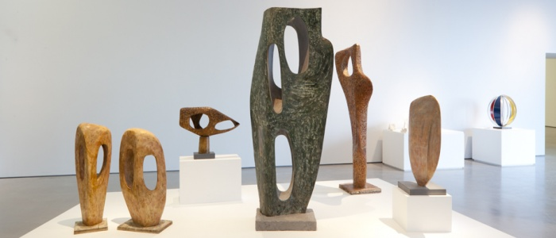

What resources will I need?
Sketchbook/scrap book
2B drawing pencil and a set of coloured pencils.

Where can I look for more activities or resources if I would like them?
Or further afield,
The Victoria and Albert Museum https://www.vam.ac.uk/
The National Portrait Gallery https://www.npg.org.uk/
The Tate Modern https://www.tate.org.uk/visit/tate-modern

What will I be studying when I return in September and how can I prepare?
New Year 8 | Students will develop their knowledge and creative skills through studies based on Landscape/perspective and the Art movement ‘Pop Art’.
New Year 9 | Students will develop knowledge and creative skills through studies based on Antoni Gaudi, Keith Haring and Natural Forms.

