DT : Optional Summer Project

What is the Optional Summer Project?
Create an ‘upcycled’ product.
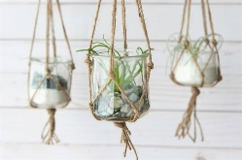
Use materials in the home or garden to create a new product.
Look at the link below for some brilliant ideas,
Glass pot planters- Use glass dessert jars to create hanging planters. Fill with pebbles (for drainage) and soils of your choice, add tiny house plants and succulent plugs, and hang with knotted twine, or string.
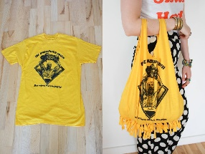
No sew T shirt bag- Make a bag from an old t shirt there are lots of tutorials for this on you tube all you need is scissors no need to sew!

What resources will I need?
Anything that you no longer use… Ask permission first!
Many ideas on the link below mentioned above, or just search upcycled projects.
https://www.loveproperty.com/gallerylist/71768/65-upcycling-ideas-to-transform-your-old-stuff
https://www.youtube.com/watch?v=zgpaM3u2zng
What will I be studying when I return in September and how can I prepare?
Year 7 | In Food you will develop your preparation skills, help at home to peel and chop vegetables when supervised. You will design and make products including a clock.
Year 8 | In Food you will develop your cooking skills to produce a range of savoury dishes, continue to help at home with cooking. You will develop making skills to manufacture a light.
Year 9 | In Food you will produce a range of pastry dishes, practice shortcrust pastry. You will be designing products inspired by Art Deco Design Movements.

