English: Optional Summer Project

What is the Optional Summer Project?
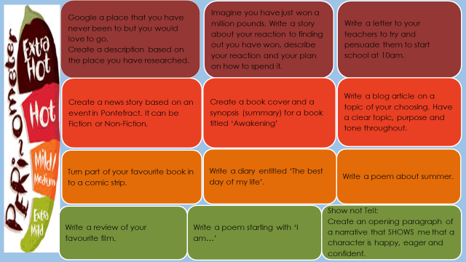
What resources will I need?
Laptop
Pen
Paper
Colouring pens or pencils
Where can I look for more activities or resources if I would like them?
https://www.thenational.academy/
https://www.bbc.co.uk/bitesize
Senaca Learning
What will I be studying when I return in September and how can I prepare?
New Year 8 | Of Mice and Men  You can prepare by using the links above to remind yourself about language analysis, Fiction and Non-Fiction writing. You could research 1930’s America and create flashcards.
New Year 9 | A View from The Bridge  You can prepare by using the links above to remind yourself about language analysis, Fiction and Non-Fiction writing. You could research 1950’s America and create flashcards. Read newspaper articles to see how they use Non-Fiction writing techniques.

