Literacy: Optional Summer Project

What is the Optional Summer Project?
Choose from the Literacy tasks below.
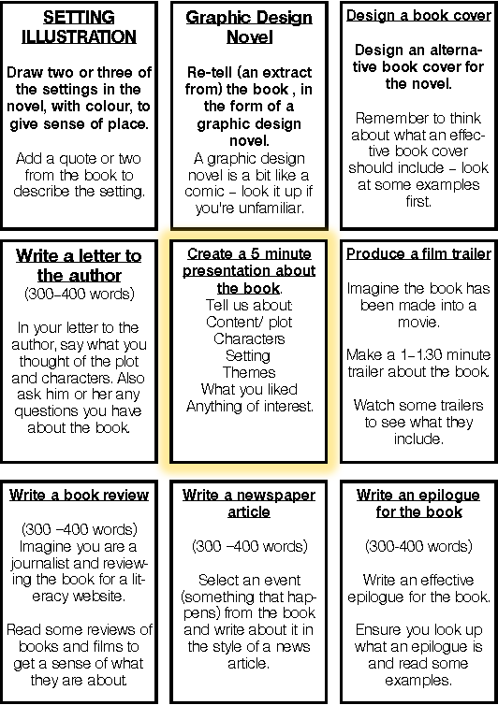

What resources will I need?
Reading books
Online reading
Audio books
Library
Articles
Film, illustration, computer, note book

Where can I look for more activities or resources if I would like them?
Accelerated Reader on TKS website

https://literacytrust.org.uk/family-zone/zone-in/

https://www.bbc.co.uk/bitesize

https://www.bbc.co.uk/sounds/category/audiobooks

What will I be studying when I return in September and how can I prepare?
New Year 8 | We actively encourage all students to read for pleasure. Young people who read regularly achieve more successful outcomes in all their subjects at school.
New Year 9

