DT : Optional Summer Project

What is the Optional Summer Project?
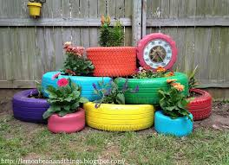
Create an ‘upcycled’ product.
Use materials in the home or garden to create a new product.
You would need supervision at home with tools, and permission from an adult at home.

The product could be manufactured using wood, plastics, and card. You could sand an old piece of furniture and finish with left over paint.

Look on the websites attached for some ideas, you could upcycle an old garment, use pallet wood to create a planter, make a phone stand from card etc.

What resources will I need?
Any materials in the home or garden that are no longer of use, wood, jars, tins, card.

Where can I look for more activities or resources if I would like them?
https://www.youtube.com/watch?v=qCvu4YnKGVY
https://www.youtube.com/watch?v=bPcXoOuDA-I
https://www.loveproperty.com/gallerylist/71768/65-upcycling-ideas-to-transform-your-old-stuff

What will I be studying when I return in September and how can I prepare?
Year 10 | In September we will cover theory work on mechanisms to review work over past term. Look at past power points on Google Classroom complete any missing worksheets to revise for the exam unit.
Year 11 | In September you will be continuing with the NEA task. We will complete specifications where you should fully have decided what you are making, the client, and theme. We will start with initial ideas. You can prepare by practising drawing techniques and starting some design ideas using isometric and 2 point perspective.

