English: Optional Summer Project

What is the Optional Summer Project?
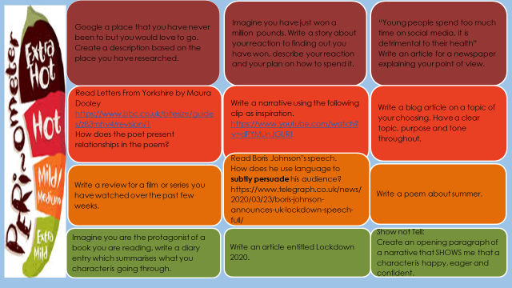
What resources will I need?
Laptop
Pen
Paper
Flashcards
Poster paper
Where can I look for more activities or resources if I would like them?
https://classroom.thenational.academy/subjects-by-year/year-10/subjects/english
https://www.bbc.co.uk/bitesize/tags/zr7447h/year-10-and-s4-lessons
Youtube – Mr Bruff
Senaca Learning
What will I be studying when I return in September and how can I prepare?
New Year 10 | An Inspector Calls  Macbeth  Conflict Poetry  Jekyll and Hyde  Narrative and Non-Fiction Writing  You can prepare by using the links above to look at context points. You could read the poems and look at the information about them on Senaca Learning.
New Year 11 | An Inspector Calls Revision  Conflict Poetry  Jekyll and Hyde or A Christmas Carol Revision  Macbeth  Non Fiction Writing and Reading  Re read the texts again. Create revision flashcards with quotes, key context and explanations of the poems / texts you have studied.

