Ks4 GCSE Drama: Optional Summer Project
What is the Optional Summer Project?
Writing a script from a given Stimulus image
- Choose one of the below images and consider the following:
- What is the storyline you imagine for the image?
- Name of the characters and their personalities and relationships to each other.
- The beginning, middle and end of the story.
- Costumes for each character.
- Write a full script for the storyline and characters. Include stage directions and at least one monologue for one character
( Monologue = one person’s speech)
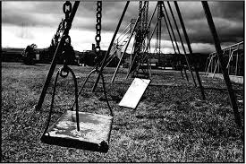
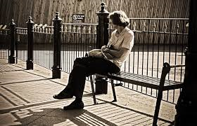
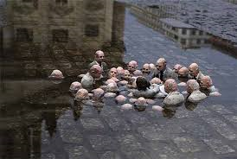
- Record yourself delivering a monologue from your script. Consider vocal, movement and interaction skills when performing.
What resources will I need?
Pen and Paper to plan and write your script on.
Recording facilities ( phone or camera)
Where can I look for more activities or resources if I would like them?
In Google write drama stimulus images and look at the images tab this will bring up thousands of images that are good for creating drama from. You can compete more script ideas from new stimuli.
Or go to BBC BITESIZE and look at how to write a script. https://www.bbc.co.uk/bitesize/topics/zkgcwmn/articles/z6hhcqt

What will I be studying when I return in September and how can I prepare?
New Year 10 | In Term 1 you will be devising for component 2. It would be useful for you to research into the following drama practitioners so you can use their influences when devising: Berkoff, Stanislavski, Brecht and Artuad.
New Year 11 | In Term 1 you will be rehearsing and performing your scripted monologues and duologues you must know your scripted extracts off by heart so you can perform in term 1.

