Y10 WORK BOOKLET
WK 3 (F)

Name: _________

ENGLISH

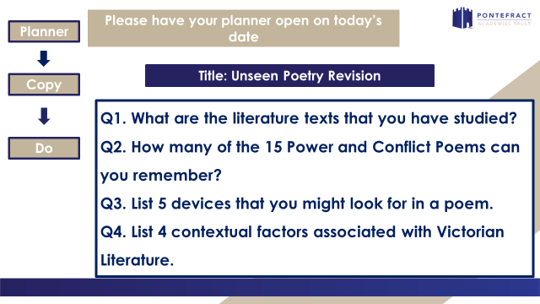

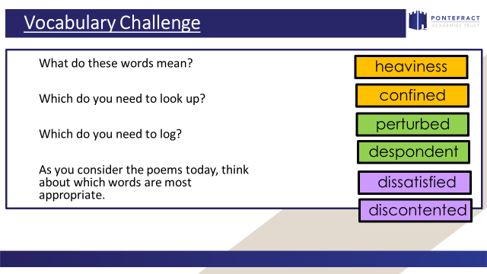

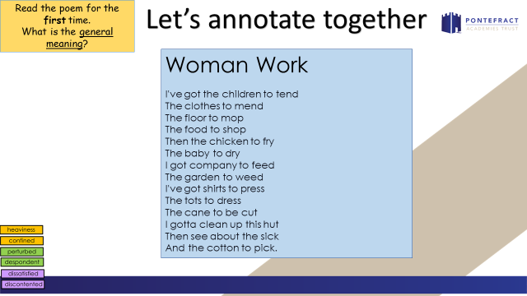

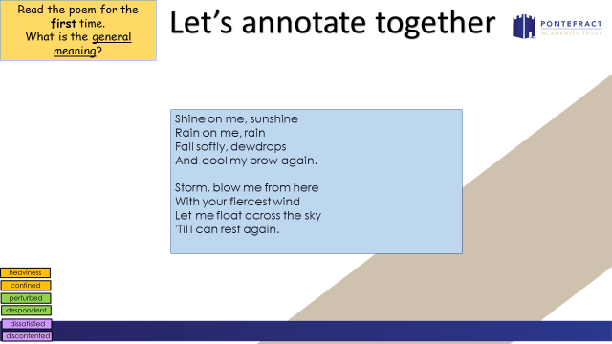

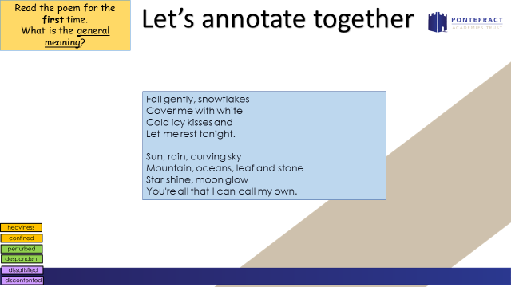

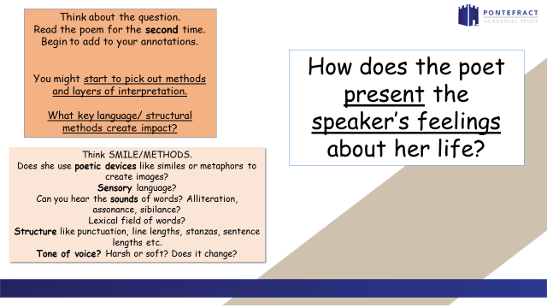

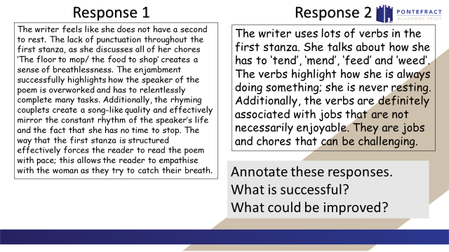

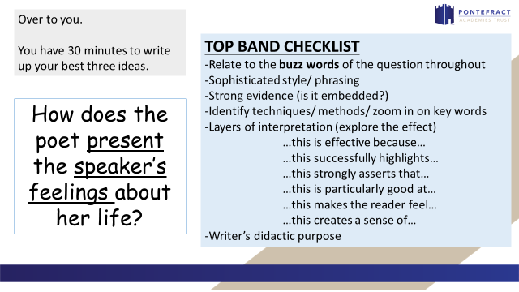

_________________________________________________________________________________________________________________________________________________________________________________________________________________________________________________________________________________________________________________________________________________________________________________________________________________________________________________________________________________________________________________________________________________________________________________________________________________________________________________________________________________________________________________________________________________________________________________________________________________________________________________________________________________________________________________________________________________________________________________________________________________________________________________________________________________________________________________________________________________________________________________________________________________________________________________________________________
_________________________________________________________________________________________________________________________________________________________________________________________________________________________________________________________________________________________________________________________________________________________________________________________________________________________________________________________________________________________________________________________________________________________________________________________________________________________________________________________________________________________________________________________________________________________________________________________________________________________________________________________________________________________________________________________________________________________________________________________________________________________________________________________________________________________________________________________________________________________________________________________________________________________________________________________________________

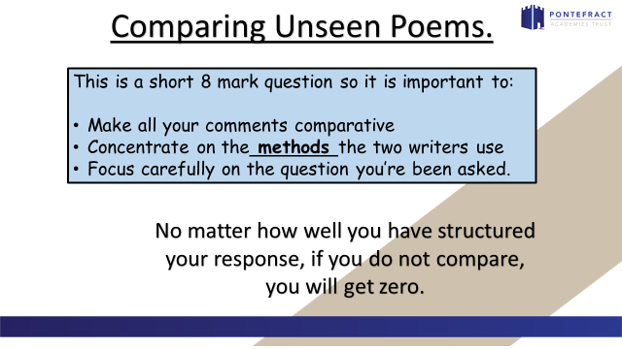

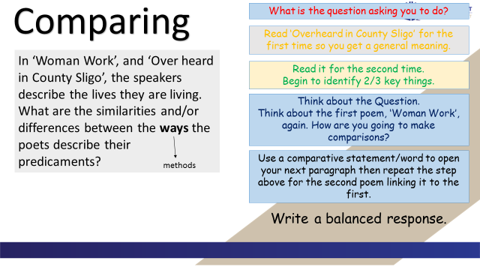

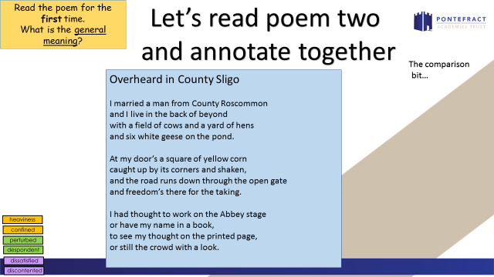

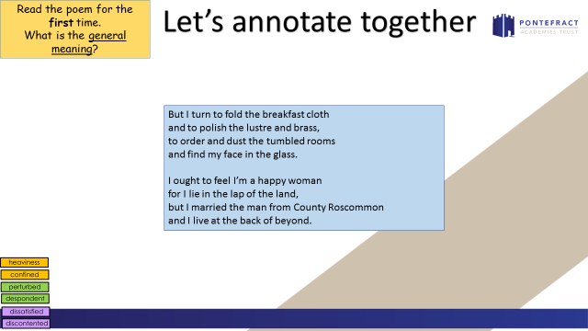

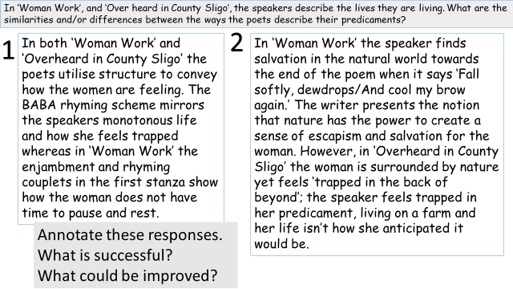

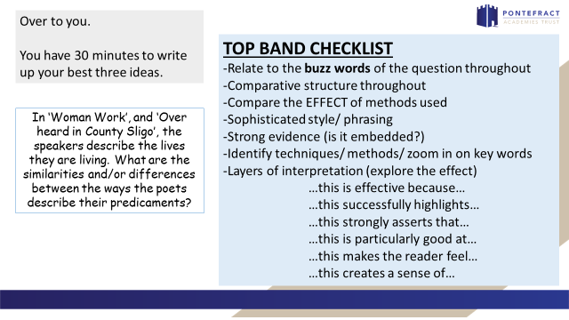

Woman Work

I've got the children to tend
The clothes to mend
The floor to mop
The food to shop
Then the chicken to fry
The baby to dry
I got company to feed
The garden to weed
I've got shirts to press
The tots to dress
The cane to be cut
I gotta clean up this hut
Then see about the sick
And the cotton to pick.

Shine on me, sunshine
Rain on me, rain
Fall softly, dewdrops
And cool my brow again.
Storm, blow me from here
With your fiercest wind
Let me float across the sky
'Til I can rest again.
Fall gently, snowflakes
Cover me with white
Cold icy kisses and
Let me rest tonight.
Sun, rain, curving sky
Mountain, oceans, leaf and stone
Star shine, moon glow
You're all that I can call my own.

Maya Angelou

Overheard in County Sligo
I married a man from County Roscommon
and I live in the back of beyond
with a field of cows and a yard of hens
and six white geese on the pond.
At my door’s a square of yellow corn
caught up by its corners and shaken,
and the road runs down through the open gate
and freedom’s there for the taking.
I had thought to work on the Abbey stage
or have my name in a book,
to see my thought on the printed page,
or still the crowd with a look.
But I turn to fold the breakfast cloth
and to polish the lustre and brass,
to order and dust the tumbled rooms
and find my face in the glass.
I ought to feel I’m a happy woman
for I lie in the lap of the land,
but I married the man from County Roscommon
and I live at the back of beyond.
Gillian Clarke

______________________________________________________________________________________________________________________________________________________________________________________________________________________________________________________________________________________________________________________________________________________________________________________________________________________________________________________________________________________________________________________________________________________________________________________________________________________________________________________________________________________________________________________________________________________________________________________________________________________________________________________________________________________________________________________________________________________________________________________________________________________________________________________________________________________________________________________________________________________________________________________________________________________________________________________________________________________________________________________________________________________________________________________________________________________________________________________________________________________________________________________________
_________________________________________________________________________________________________________________________________________________________________________________________________________________________________________________________________________________________________________________________________________________________________________________________________________________________________________________________________________________________________________________________________________________________________________________________________________________________________________________________________________________________________________________________________________________________________________________________________________________________________________________________________________________________________________________________________________________________________________________________________________________
MATHS(2)

PCD

Task 1

Task 2

Task 3

Task 4

Task 5

Task 6

Task 7

Task 8

Task 9

Task 10

Task 11

MATHS (3)

PCD

Task 1

Task 2

Task 3

Task 4

Task 5

Task 6

Task 7

Task 8

Task 9

Task 10

SCIENCE

REMINDERS - COMBINED SCIENCE TRILOGY TOPICS and REQUIRED PRACTICALS
Paper 1 |  | Paper 2
Biology | Cell Biology  - Microscopy  - Osmosis | Biology | Homeostasis  6. Reaction times
 | Organisation  - Food tests  - Effect of pH on enzymes |  | Inheritance
 | Infection |  | Ecology  7. Distribution – Sampling techniques
Bioenergetics
- Photosynthesis
Chemistry | Atomic Structure | Chemistry | Rate and extent of chemical change  11. Rates of reactions
 | Structures and Bonding |  | Organic Chemistry
 | Quantitative Chemistry |  | Chemical analysis  12. Chromatography
 | Chemical changes  8. Making Salts  9. Electrolysis |  | Chemistry of the atmosphere
 | Energy changes  10. Temperature changes |  | Using resources  13. analysis and purification of water
Physics | Energy  14. Specific Heat Capacity | Physics | Forces  18. Hookes Law  19. Acceleration
 | Electricity  15. Resistance of a wire / of resistors in series and parallel  16. I-V characteristics |  | Waves  20. Waves in water and solids  21. Surfaces and radiation
 | Particle model of matter  17. Density |  | Magnets and electromagnets

PART 1 – CONTENT
ATOMIC STRUCTURE

What is an atom?
____________________________________________________________________________________________________________________________________________
What is the definition of an element?
____________________________________________________________________________________________________________________________________________
What is the definition of a compound?
____________________________________________________________________________________________________________________________________________
Why do elements form compounds?
____________________________________________________________________________________________________________________________________________

The structure of an atom – Label each part of the atom including name, charge and mass.

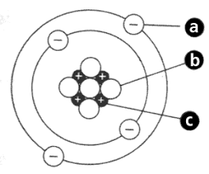

Why are atoms neutral overall?
______________________________________________________________________

EXAMPLE QUESTION
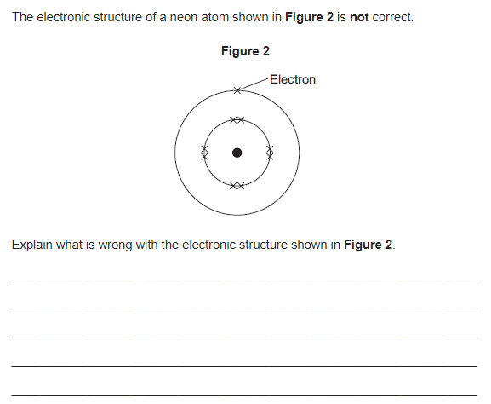
Hint:
How many electrons should there be on each shell?
How many electrons should there be in total?

LINKING ATOMIC STRUCTURE AND THE PERIODIC TABLE
What information can we find out about an atom by looking at its position on the periodic table?
List your ideas below:
Hint:
- What does the group number tell us?

- What does the period (row) tell us?

- What does the atomic number tell us?

- What does the mass tell us?

EXAMPLE QUESTION
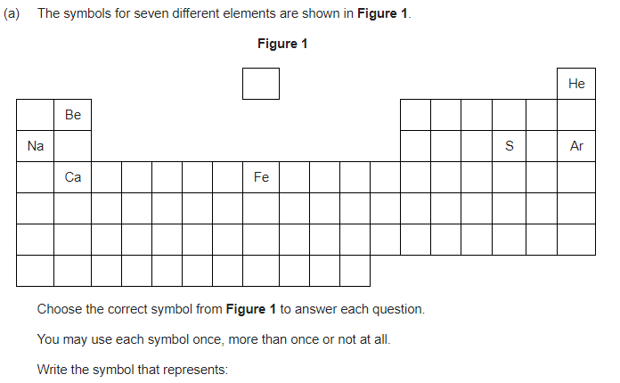
An element with 1 electron in its outer shell
______________________________________________________________________
Two elements with the same number of electrons in their outer shell
______________________________________________________________________
Two elements with the same number of shells ______________________________________________________________________
An element with a full outer shell ______________________________________________________________________

PART 2 CONTENT – STRUCTURE AND BONDING
IONIC BONDS

What can you remember about ionic bonds?

Ionic bonds

Why do elements form bonds with other elements? (Hint- what are they trying to achieve in terms of electron shells?)
____________________________________________________________________________________________________________________________________________
Which elements form ionic bonds?
____________________________________________________________________________________________________________________________________________

In ionic bonding metal atoms _________ their outer electrons and become ______________ charged ions, non- metal atoms _______________ electrons to obtain a full outer shell and become ______________ charged ions. (Hint which loses and which gains electrons)

What is an ion?
______________________________________________________________________

EXAMPLE QUESTION
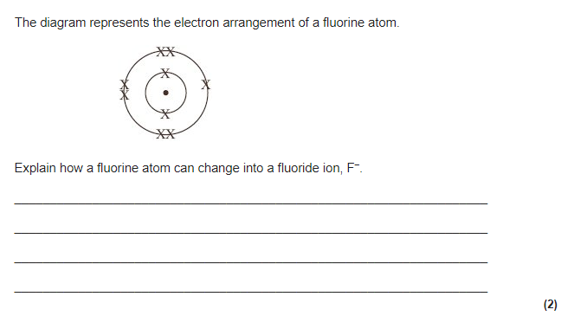
Hint: count the electrons on the outer shell.
How can it fill this shell?

LINKS TO ATOMIC STRUCURE AND PERIODIC TABLE
Using your of the Periodic table and electronic structure fill in the table below.

Name of the element | Group number | Number of electrons in the outer shell | How does it obtain a full outer shell | Charge of the ion formed
Sodium
Magnesium
Oxygen
Chlorine

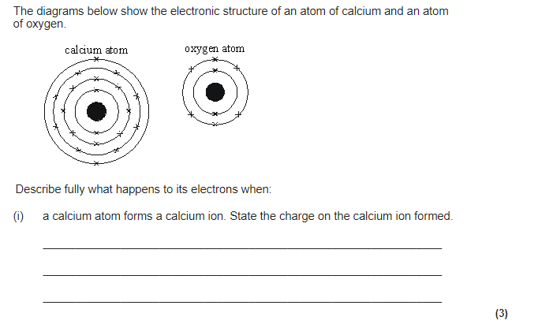
Use the table above to help you.
Check the Periodic table to find out which group these elements are in.
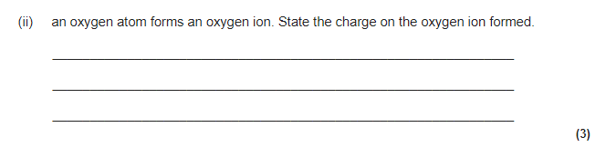

What is an ionic bond?
The ions will be …………
What is the name of the force that holds them together?
Describe the strength of this force.
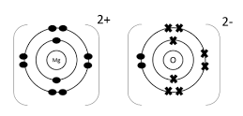
________________________________________________________________________________________________________________________________________________________________________________________________________________________________________________________________________________________
Describe the structure of an ionic compound.
________________________________________________________________________________________________________________________________________________________________________________________________________________________________________________________________________________________
EXAMPLE QUESTION
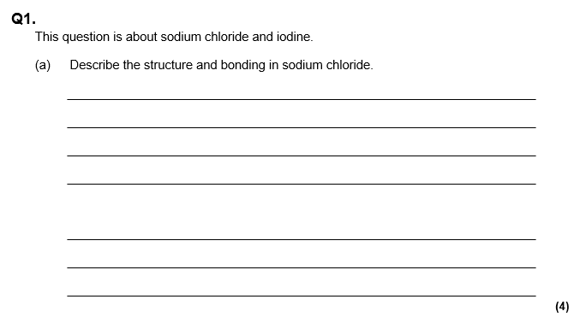
The structure is…

The type of bond is called a

The name of the force is..

This force is between opposite ..

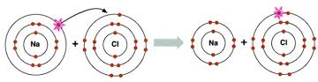
How is sodium chloride produced from sodium and chlorine? Answer in terms of electrons.
__________________________________________________________________________________________________________________________________________________________________________________________________________________________________________________________________________________________________________________________________________________________________________________________________________________________________________________________________________________________________________
EXAMPLE QUESTION
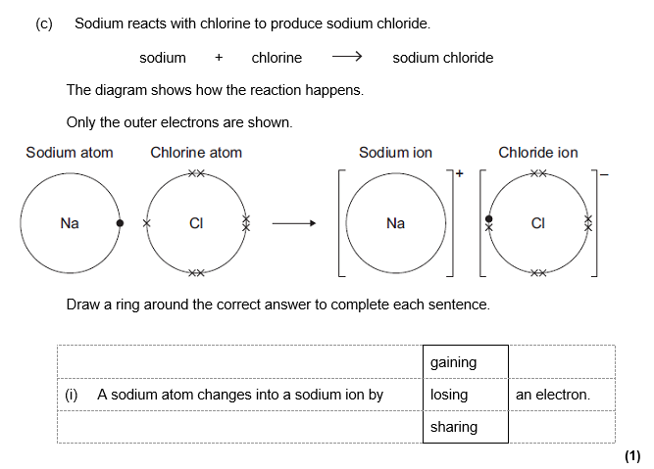
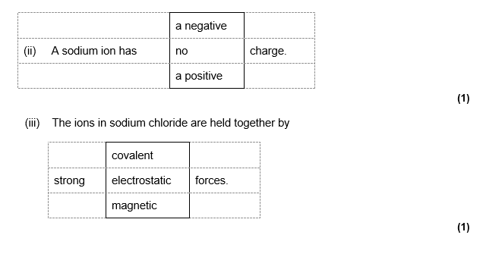
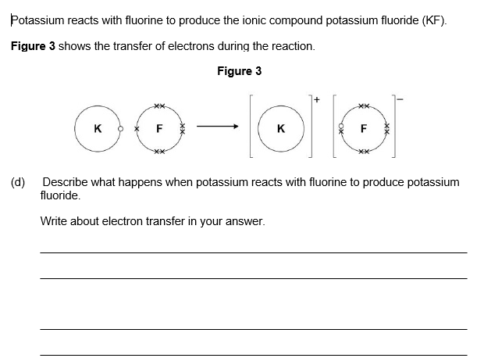

IONIC BONDS AND THEIR PROPERTIES
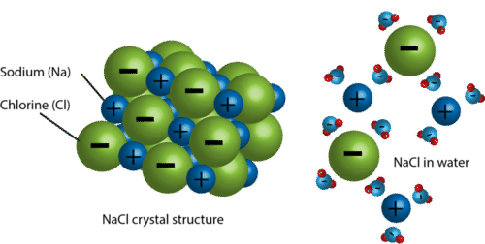
Why do ionic compounds have high melting and boiling points?
Hint: What can we say about the strength of the electrostatic force? ______________________________________________________________________________________________________________________________________________________________________________________________________________________________________________________________________________________________________________________________________________________________
Why do ionic compounds dissolve in water?
Hint: what are the water molecules doing to the lattice?
______________________________________________________________________________________________________________________________________________________________________________________________________________________________________________________________________________________________________________________________________________________________
Why do ionic compounds conduct electricity when molten or dissolved in water but not when solid?
Hint: what do the ions need to be able to do to carry a charge throughout the whole substance?
______________________________________________________________________________________________________________________________________________________________________________________________________________________________________________________________________________________________________________________________________________________________

EXAMPLE QUESTIONS
Calcium carbonate has a high melting point and is a solid at room temperature.
As a solid it is unable to conduct electricity, but when melted or dissolved in water it is able to conduct electricity.
Explain In terms of structure and bonding why. Use the diagrams and information above to help you.
Calcium carbonate has a high melting point and is a solid at room temperature (3)
_______________________________________________________________________________
_______________________________________________________________________________
_______________________________________________________________________________
_______________________________________________________________________________
_______________________________________________________________________________
_______________________________________________________________________________
_______________________________________________________________________________
Solid calcium carbonate is unable to conduct electricity (2)
_______________________________________________________________________________
_______________________________________________________________________________
_______________________________________________________________________________
_______________________________________________________________________________
_______________________________________________________________________________
_______________________________________________________________________________
_______________________________________________________________________________
Calcium carbonate is able to conduct electricity when melted or dissolved in water (2)
_______________________________________________________________________________
_______________________________________________________________________________
_______________________________________________________________________________
_______________________________________________________________________________
_______________________________________________________________________________
_______________________________________________________________________________

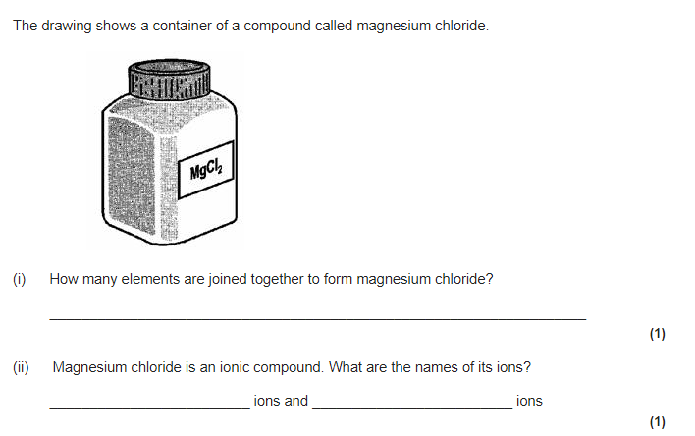
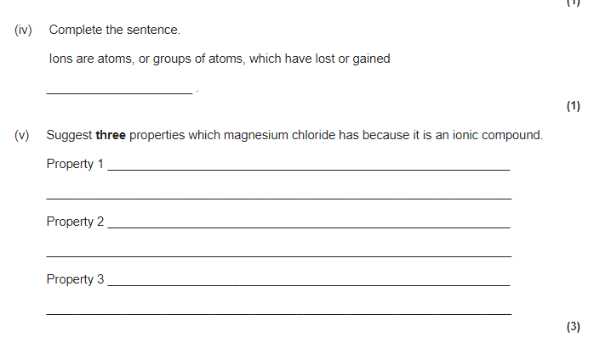

PART 3 - ELECTROLYSIS
Write down everything you know about electrolysis.

Electrolysis

What is the definition of electrolysis?
__________________________________________________________________________________________________________________________________________________________________________________________________________________

Add labels to the diagram below: Anode, cathode, electrolyte.
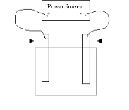

What do we mean by the electrolyte?
____________________________________________________________________________________________________________________________________________

LINKING ELECTROLYSIS TO IONIC COMPOUND PROPERTIES
Electrolysis separates ionic compounds into their original elements using electricity.
Why do ionic compounds need to be molten or dissolved to undergo electrolysis?
The ions need to be able to _________________. They cannot do this when the ionic compound is a _________________.

EXAMPLE QUESTION
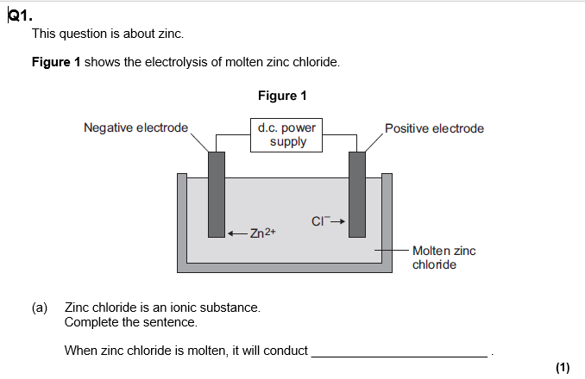
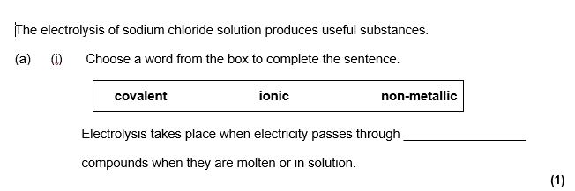

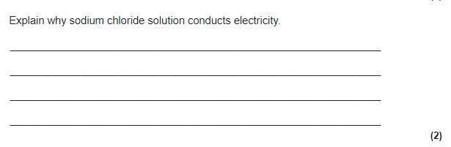
Recap from ionic bonding
What is an ion?
____________________________________________________________________________________________________________________________________________
How are metal ions formed? (What happens in terms of electrons?)
______________________________________________________________________
How are non-metal ions formed? (What happens in terms of electrons?)
______________________________________________________________________

Electrolysis involves turning an ion back into a neutral atom. Using the information above, how atoms formed from ions.
Metal element (What happens in terms of electrons?):
______________________________________________________________________
Non-metal element (What happens in terms of electrons?):
______________________________________________________________________

Why do metal ions move towards the cathode (Think about the charges)?
____________________________________________________________________________________________________________________________________________

Why do non-metal ions move towards the anode (Think about the charges)?
____________________________________________________________________________________________________________________________________________

Fill in the table below:
Name of compound | Element formed at the anode | Element formed at the cathode
Lithium fluoride
Magnesium oxide
Potassium iodide
Sodium chloride
Beryllium bromide

EXAMPLE QUESTION
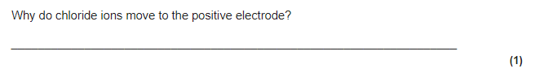

EXAMPLE QUESTION
