Y10 WORK BOOKLET
WK 4 (H)

Name: _________

MATHS (1)

PCD

TASK 1

TASK 2

TASK 3

TASK 4

TASK 5

TASK 6

TASK 7

TASK 8

TASK 9

TASK 10

MATHS (2)

PCD

TASK 1

TASK 2

TASK 3

TASK 4

TASK 5

TASK 6

TASK 7

TASK 8

TASK 9

TASK 10

ENGLISH

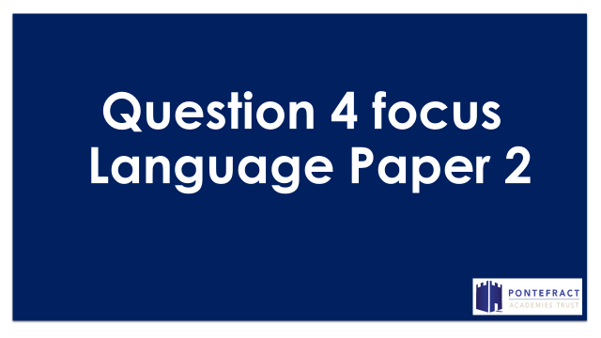
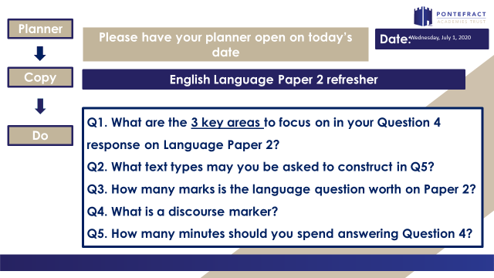

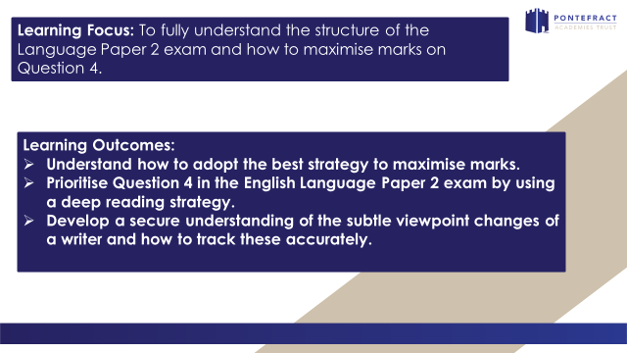
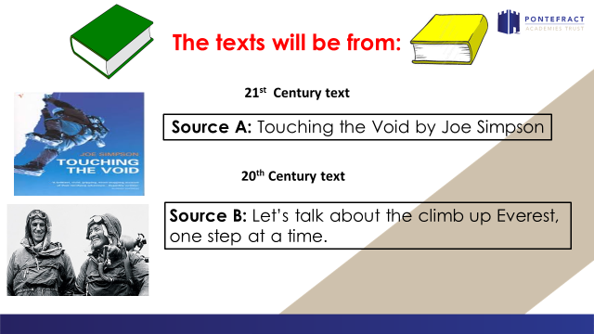
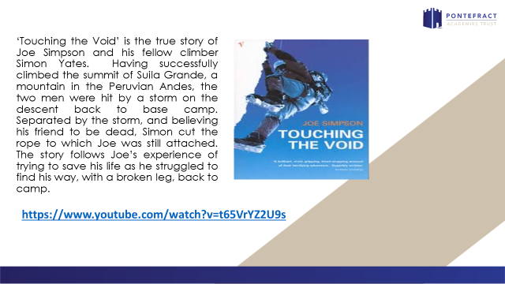
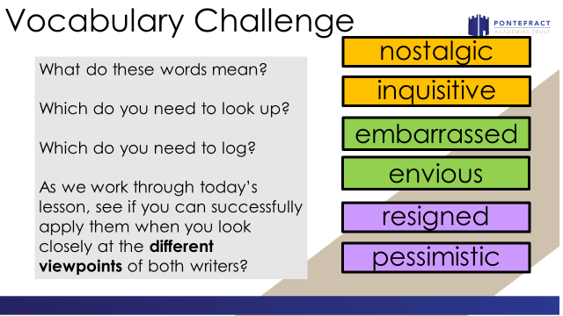
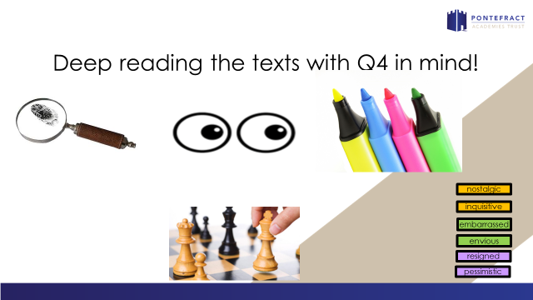
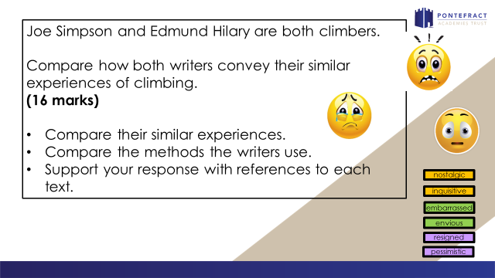
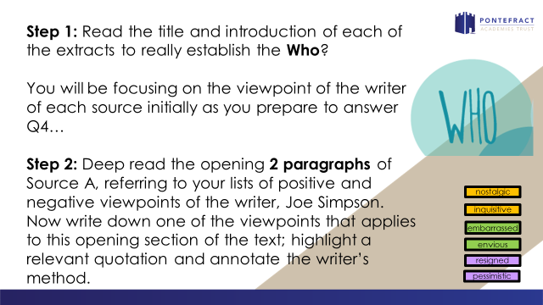
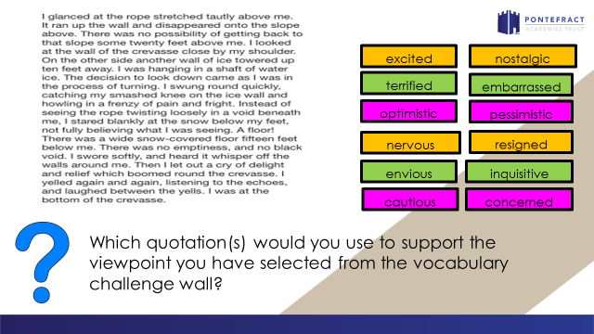
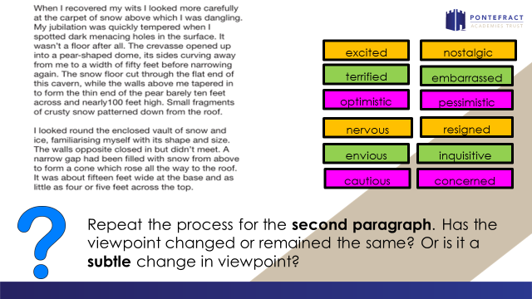
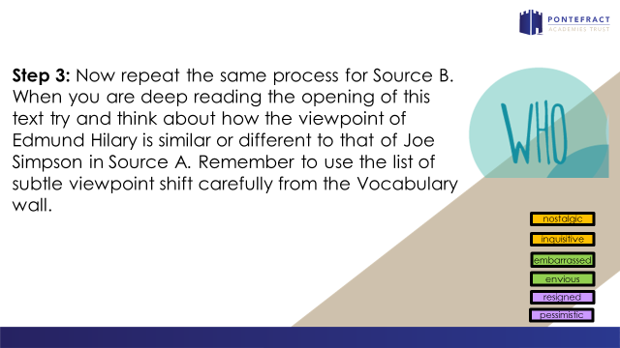
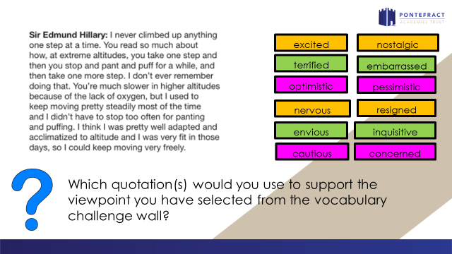
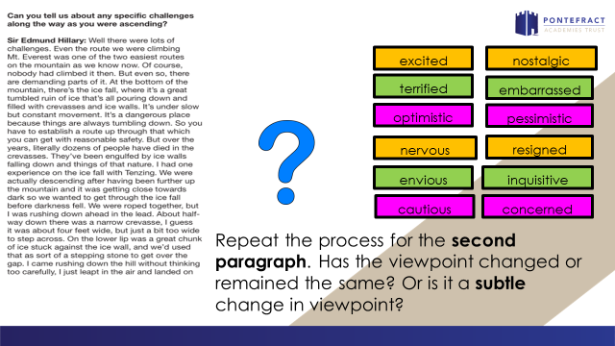
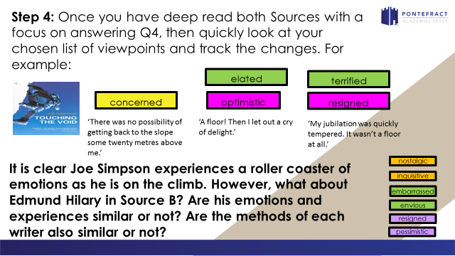
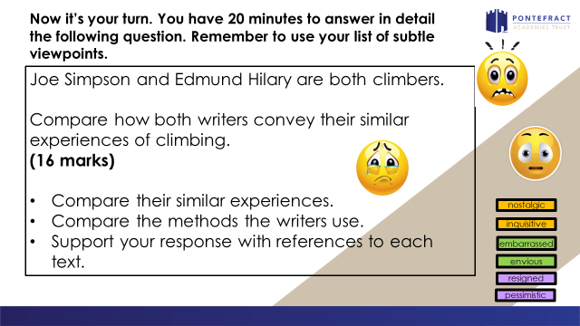
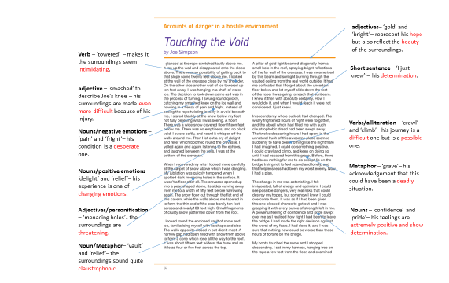

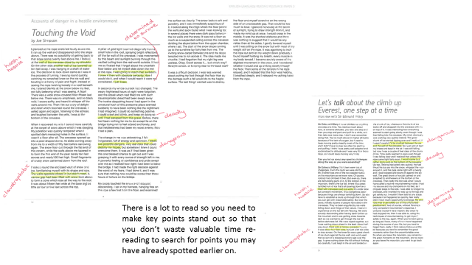

Source A: An extract from Touching the Void by Joe Simpson
I glanced at the rope stretched tautly above me. It ran up the wall and disappeared onto the slope above. There was no possibility of getting back to that slope some twenty feet above me. I looked at the wall of the crevasse close by my shoulder. On the other side another wall of ice towered up ten feet away. I was hanging in a shaft of water ice. The decision to look down came as I was in the process of turning. I swung round quickly, catching my smashed knee on the ice wall and howling in a frenzy of pain and fright. Instead of seeing the rope twisting loosely in a void beneath me, I stared blankly at the snow below my feet, not fully believing what I was seeing. A floor! There was a wide snow-covered floor fifteen feet below me. There was no emptiness, and no black void. I swore softly, and heard it whisper off the walls around me. Then I let out a cry of delight and relief which boomed round the crevasse. I yelled again and again, listening to the echoes, and laughed between the yells. I was at the bottom of the crevasse.
When I recovered my wits I looked more carefully at the carpet of snow above which I was dangling. My jubilation was quickly tempered when I spotted dark menacing holes in the surface. It wasn’t a floor after all. The crevasse opened up into a pear-shaped dome, its sides curving away from me to a width of fifty feet before narrowing again. The snow floor cut through the flat end of this cavern, while the walls above me tapered in to form the thin end of the pear barely ten feet across and nearly100 feet high. Small fragments of crusty snow patterned down from the roof.
I looked round the enclosed vault of snow and ice, familiarising myself with its shape and size. The walls opposite closed in but didn’t meet. A narrow gap had been filled with snow from above to form a cone which rose all the way to the roof. It was about fifteen feet wide at the base and as little as four or five feet across the top.
A pillar of gold light beamed diagonally from a small hole in the roof, spraying bright reflections off the far wall of the crevasse. I was mesmerised by this beam and sunlight burning through the vaulted ceiling from the real world outside. It had me so fixated that I forgot about the uncertain floor below and let myself slide down the rest of the rope. I was going to reach that sunbeam. I knew it then with absolute certainty. How I would do it, and when I would reach it were not considered. I just knew.
In seconds my whole outlook had changed. The weary frightened hours of night were forgotten, and the abseil which had filled me with such claustrophobic dread had been swept away. The twelve despairing hours I had spent in the unnatural hush of this awesome place seemed suddenly to have been nothing like the nightmare I had imagined. I could do something positive. I could crawl and climb, and keep on doing so until I had escaped from this grave. Before, there had been nothing for me to do except lie on the bridge trying not to feel scared and lonely, and that helplessness had been my worst enemy. Now I had a plan.
The change in me was astonishing. I felt invigorated, full of energy and optimism. I could see possible dangers, very real risks that could destroy my hopes, but somehow I knew I could overcome them. It was as if I had been given this one blessed chance to get out and I was grasping it with every ounce of strength left in me. A powerful feeling of confidence and pride swept over me as I realised how right I had been to leave the bridge. I had made the right decision against the worst of my fears. I had done it, and I was sure that nothing now could be worse than those hours of torture on the bridge.
My boots touched the snow and I stopped descending. I sat in my harness, hanging free on the rope a few feet from the floor, and examined the surface cautiously. The snow looked soft and powdery, and I was immediately suspicious of it. I looked along the edge where the floor joined the walls and soon found what I was looking for. In several places there were dark gaps between the ice walls and the snow. It was not a floor so much as a suspended ceiling across the crevasse dividing the abyss below from the upper chamber, where I sat. The start of the snow slope running up to the sunshine lay forty feet from me. The inviting snow-carpet between me and the slope tempted me to run across it. The idea made me chuckle. I had forgotten that my right leg was useless. Okay. Crawl across it… but which way? Straight across, or keeping near to the back wall?
It was a difficult decision. I was less worried about putting my foot through the floor than by the damage such a fall would do to the fragile surface. The last thing I wanted was to destroy the floor and myself stranded on the wrong side of an uncrossable gap. That would be too much to bear. I glanced nervously at the beam of sunlight, trying to draw strength from it, and made my mind up at once. I would cross in the middle. It was the shortest distance and there was nothing to suggest that it would be any riskier than at the sides. I gently lowered myself until I was sitting on the snow but with most of my weight still on the rope. It was agonising to inch the rope out and let my weight down gradually. I found myself holding my breath, every muscle in my body tensed. I became acutely aware of the slightest movement in the snow, and I wondered whether I would end up sinking slowly through the floor. Then some of the tension in the rope relaxed, and I realised that the floor was holding. I breathed deeply, and I released my aching hand from the rope.

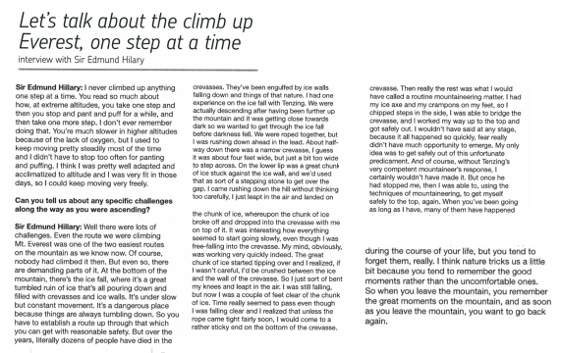
_________________________________________________________________________________________________________________________________________________________________________________________________________________________________________________________________________________________________________________________________________________________________________________________________________________________________________________________________________________________________________________________________________________________________________________________________________________________________________________________________________________________________________________________________________________________________________________________________________________________________________________________________________________________________________________________________________________________________________________________________________________________________________________________________________________________________________________________________________________________________________________________________________________________________________________________________________
_________________________________________________________________________________________________________________________________________________________________________________________________________________________________________________________________________________________________________________________________________________________________________________________________________________________________________________________________________________________________________________________________________________________________________________________________________________________________________________________________________________________________________________________________________________________________________________________________________________________________________________________________________________________________________________________________________________________________________________________________________________________________________________________________________________________________________________________________________________________________________________________________________________________________________________________________________
______________________________________________________________________________________________________________________________________________________________________________________________________________________________________________________________________________________________________________________________________________________________________________________________________________________________________________________________________________________________________________________________________________________________________________________________________________________________________________________________________________________________________________________________________________________________________________________________________________________________________________________________________________________________________________________________________________________________________________________________________________________________________________________________________________________________________________________________________________________________________________________________________________________________________________________________________________________________________________________________________________________________________________________________________________________________________________________________________________________________________________________________
____________________________________________________________________________________________________________________________________________________________________________________________________________________________________________________________________________________________________________________________________________________________________________________________________________________________________________________________________________________________________________________________________________________________________________________________________________________________________________________________________________________________________________________________________________________________________________________________________________________________________________________________________________________________________________________________________________________________________________________________________________________

SCIENCE

Energy - Revisit
Task 1: Complete the table to match the energy store to its description.
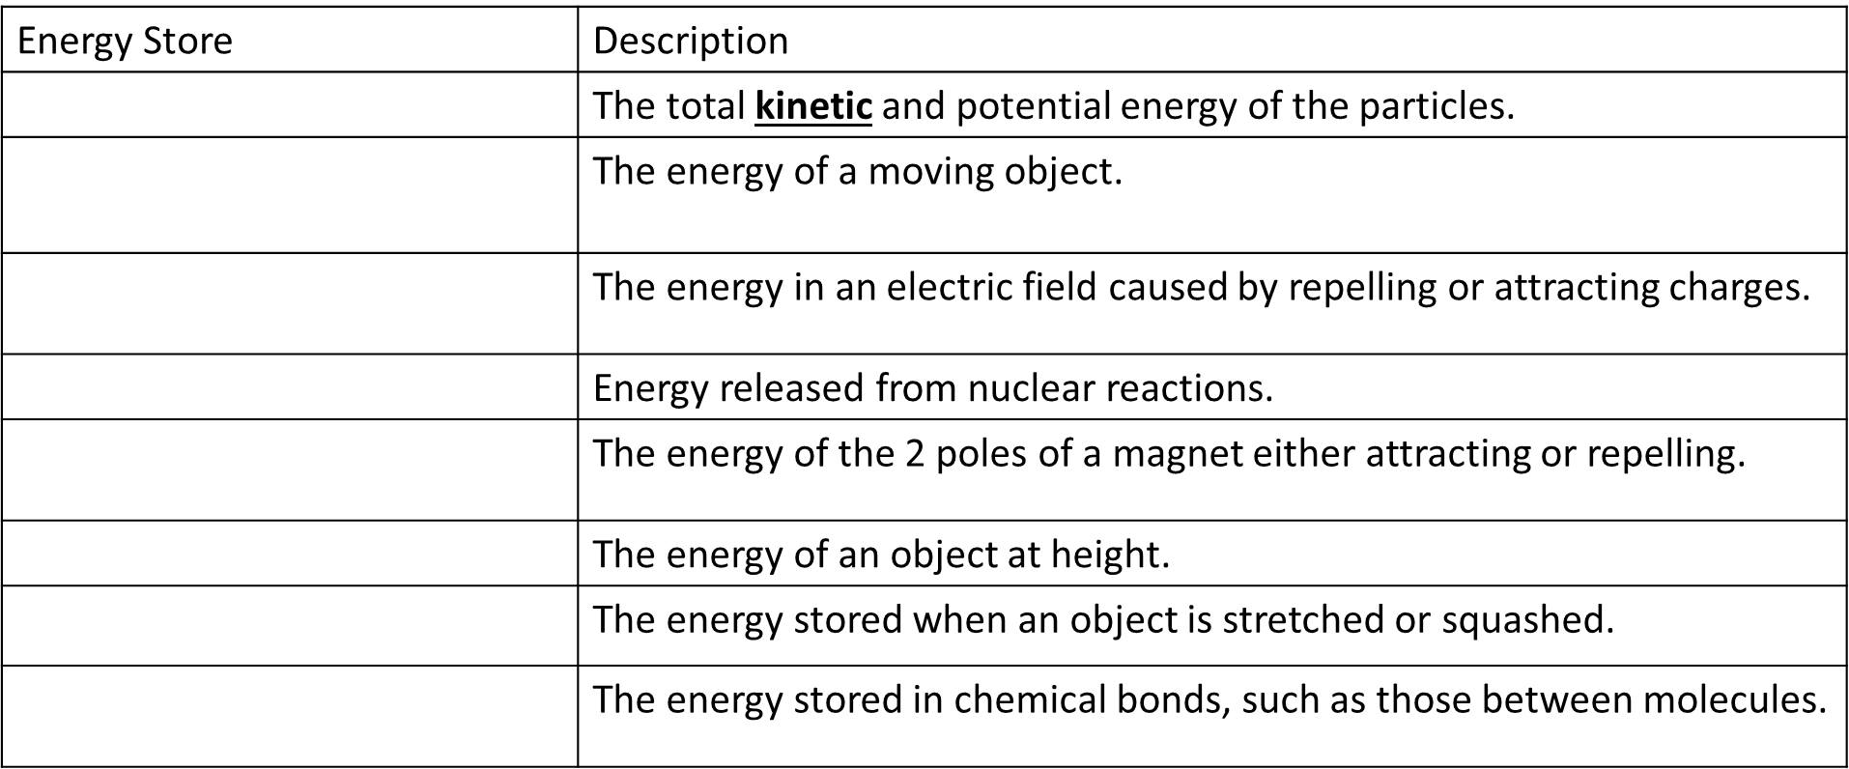
Task 2:
- Write down the formula that links power, energy and time.

- Complete the table below:
Device | Energy transferred | Time taken | Power
Kettle | 324kJ | 3 MINUTES
Toaster | 405kJ | 1.5 MINUTES
Laptop |  | 3 HOURS | 50W
TV | 993.6kJ |  | 138W
Water heater |  | 45MINUTES | 12.5kW
(* Note 1kW is 1000W, kJ = 1000J, 1 MINUTE IS 60 SECONDS, 1 HOUR IS 60 INUTES)
- Which device is the most powerful? How do you know?

Task 3:
- State the formula for
  - Work done

  - Gravitational potential energy

  - Kinetic Energy

  - Elastic Potential energy

- A high jumper has a mass of 78kg. Calculate the weight of the high jumper (Gravitational field strength is 9.8n/kg)
Weight = mass x gravitational field strength

- Calculate the work done to lift the high jumper 2.3m above the ground.

- Calculate the maximum gravitational potential energy of the high jumper when he completes a 2.5m high jump.

- If you assume all the energy is converted to kinetic energy what is the speed of the high jumper when he hits the ground?

Electricity –Revisit

Task 4: A student needs to find the resistance of a lamp.
- Add a voltmeter to the circuit below that could be used to find the potential difference across the lamp.

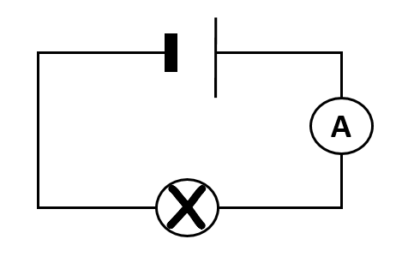

- Calculate the resistance of the lamp when the ammeter read 1.3A and the voltmeter reads 4.2V.

- What would happen to the resistance of the bulb if it got hotter?

Task 5: Sketch an I-V graph and explain its shape for each of the components.
An ohmic resistor | A lamp | A diode

Task 6: Complete the table below to describe how current, resistance and voltage behave in series and parallel.

 | Current | Potential difference | Resistance.
Series
Parallel

Exam Questions.
Q1. (a) Electrical circuits often contain resistors.
The diagram shows two resistors joined in series.
Calculate the total resistance of the two resistors.
__________________________________________________________________
Total resistance = _________________________ Ω
(1)
(b) A circuit was set up as shown in the diagram. The three resistors are identical.
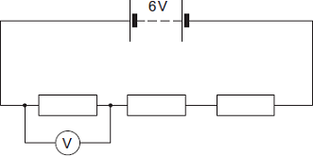
(i) Calculate the reading on the voltmeter.
______________________________________________________________
______________________________________________________________
Reading on voltmeter = _________________________ V
(2)
(ii) The same circuit has now been set up with two ammeters.
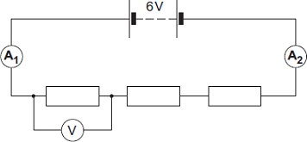
Draw a ring around the correct answer in the box to complete the sentence.

 | smaller than
The reading on ammeter A₂ will be | equal to | the reading on ammeter A₁.
 | greater than
(1)
(Total 4 marks)
Q2.
(a) The resistance of a 24 W, 12 V filament lamp depends on the current flowing through the lamp. For currents up to 0.8 A, the resistance has a constant value of 2.5 Ω.
(i) Use the equation in the box to calculate the potential difference across the lamp when a current of 0.8 A flows through the lamp.

potential difference = current × resistance
Show clearly how you work out your answer.
______________________________________________________________
______________________________________________________________
Potential difference = ______________________________ V
(2)
(ii) When the potential difference across the lamp is 12 V, the current through the lamp is 2 A.
On the axes below, draw a current–potential difference graph for the filament lamp over the range of potential difference from 0 to 12 volts.
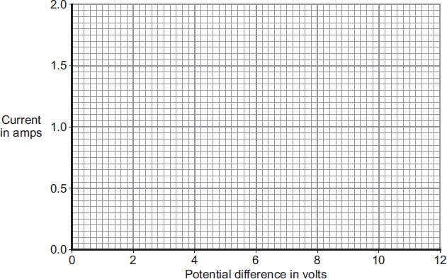
(2)
(iii) Why does the resistance of the lamp change when the current through the lamp exceeds 0.8 A?
______________________________________________________________
______________________________________________________________
(1)

Q3.
(a) The graphs, A, B and C, show how the current through a component varies with the potential difference (p.d.) across the component.
Draw a line to link each graph to the correct component.
Draw only three lines.
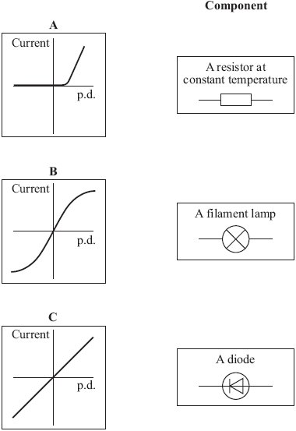
(2)

Q4. A student built a circuit using filament lamps.
(a) Sketch a current potential difference graph for a filament lamp on Figure 1
Figure 1
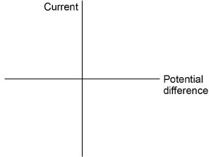
(2)
Figure 2 shows the circuit with two identical filament lamps.
Figure 2
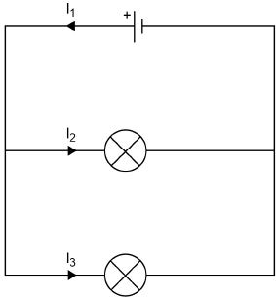
(b) Compare the currents I₁, I₂ and I₃
___________________________________________________________________
___________________________________________________________________
___________________________________________________________________
(2)

(c) Calculate the charge that flows through the cell in 1 minute.
Each filament lamp has a power of 3 W and a resistance of 12 Ω
Write any equations that you use. You need to know:
Power = Current² x Resistance
Give the unit.
___________________________________________________________________
___________________________________________________________________
___________________________________________________________________
___________________________________________________________________
___________________________________________________________________
___________________________________________________________________
Charge = _________________
Unit = _________________
(6)

