Y10 WORK BOOKLET
WK 3 (H)

Name: _________

ENGLISH

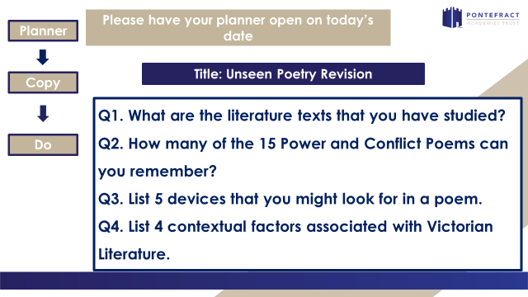

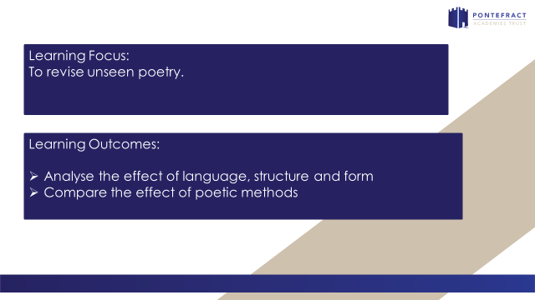

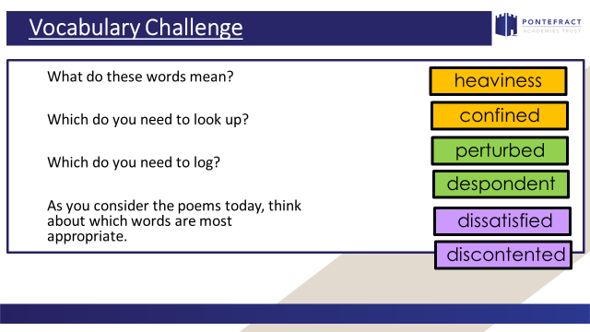

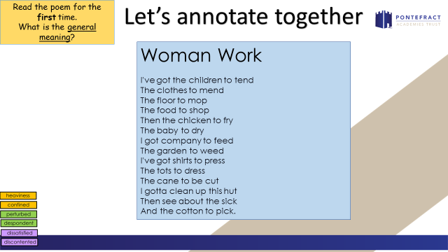

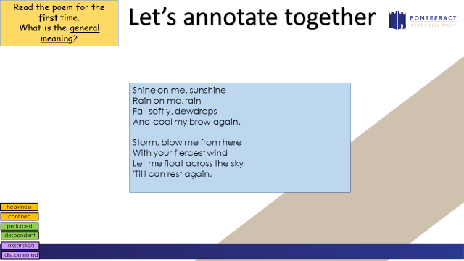

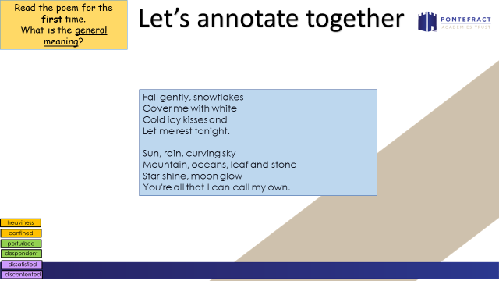

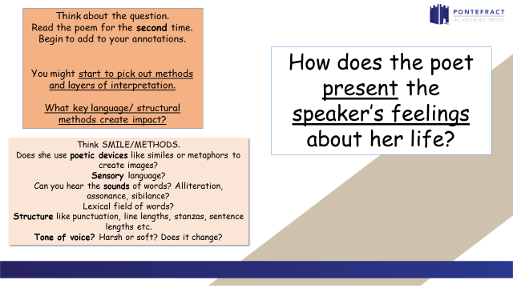

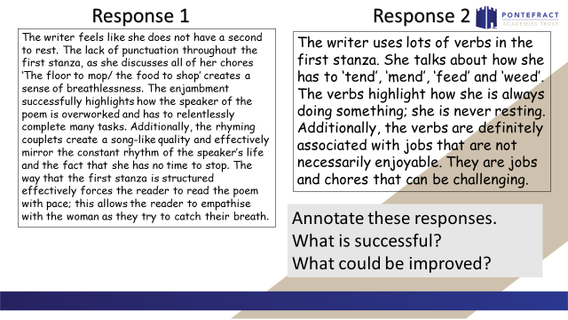

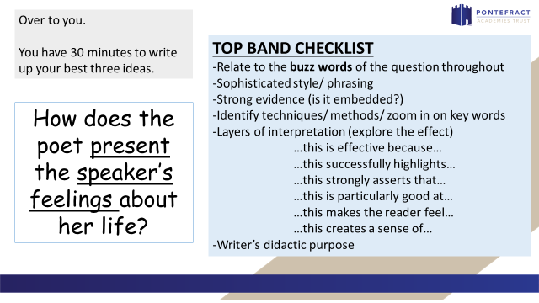

_________________________________________________________________________________________________________________________________________________________________________________________________________________________________________________________________________________________________________________________________________________________________________________________________________________________________________________________________________________________________________________________________________________________________________________________________________________________________________________________________________________________________________________________________________________________________________________________________________________________________________________________________________________________________________________________________________________________________________________________________________________________________________________________________________________________________________________________________________________________________________________________________________________________________________________________________________
_________________________________________________________________________________________________________________________________________________________________________________________________________________________________________________________________________________________________________________________________________________________________________________________________________________________________________________________________________________________________________________________________________________________________________________________________________________________________________________________________________________________________________________________________________________________________________________________________________________________________________________________________________________________________________________________________________________________________________________________________________________________________________________________________________________________________________________________________________________________________________________________________________________________________________________________________________

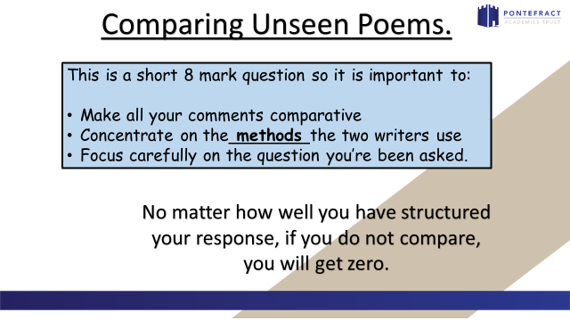

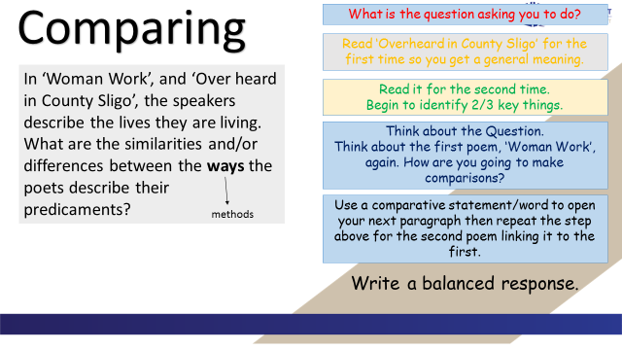

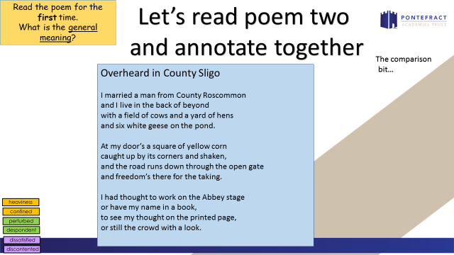

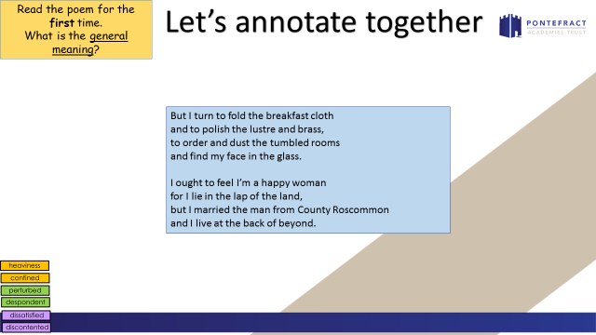

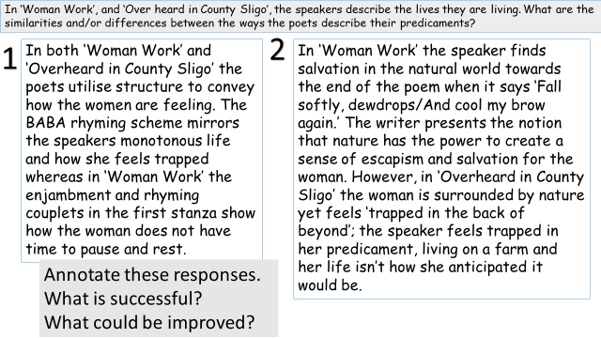

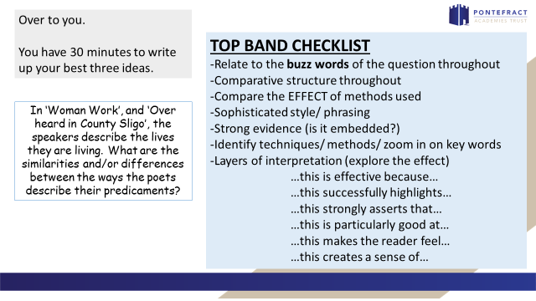

Woman Work

I've got the children to tend
The clothes to mend
The floor to mop
The food to shop
Then the chicken to fry
The baby to dry
I got company to feed
The garden to weed
I've got shirts to press
The tots to dress
The cane to be cut
I gotta clean up this hut
Then see about the sick
And the cotton to pick.

Shine on me, sunshine
Rain on me, rain
Fall softly, dewdrops
And cool my brow again.
Storm, blow me from here
With your fiercest wind
Let me float across the sky
'Til I can rest again.
Fall gently, snowflakes
Cover me with white
Cold icy kisses and
Let me rest tonight.
Sun, rain, curving sky
Mountain, oceans, leaf and stone
Star shine, moon glow
You're all that I can call my own.

Maya Angelou

Overheard in County Sligo
I married a man from County Roscommon
and I live in the back of beyond
with a field of cows and a yard of hens
and six white geese on the pond.
At my door’s a square of yellow corn
caught up by its corners and shaken,
and the road runs down through the open gate
and freedom’s there for the taking.
I had thought to work on the Abbey stage
or have my name in a book,
to see my thought on the printed page,
or still the crowd with a look.
But I turn to fold the breakfast cloth
and to polish the lustre and brass,
to order and dust the tumbled rooms
and find my face in the glass.
I ought to feel I’m a happy woman
for I lie in the lap of the land,
but I married the man from County Roscommon
and I live at the back of beyond.
Gillian Clarke

______________________________________________________________________________________________________________________________________________________________________________________________________________________________________________________________________________________________________________________________________________________________________________________________________________________________________________________________________________________________________________________________________________________________________________________________________________________________________________________________________________________________________________________________________________________________________________________________________________________________________________________________________________________________________________________________________________________________________________________________________________________________________________________________________________________________________________________________________________________________________________________________________________________________________________________________________________________________________________________________________________________________________________________________________________________________________________________________________________________________________________________________
___________________________________________________________________________________________________________________________________________________________________________________________________________________________________________________________________________________________________________________________________________________________________________________________________________________________________________________________________________________________________________________________________________________________________________________________________________________________________________________________________________________________________________________________________________________________________________________________________________________________________________________________________________________________________________________________________________________________________________________________________________________
MATHS (1)

PCD

Task 1

Task 2

Task 3

Task 4

Task 5

Task 6

Task 7

Task 8

Task 9

Task 10

MATHS (2)

PCD

Task 1

Task 2

Task 3

Task 4

Task 5

Task 6

Task 7

Task 8

Task 9

Task 10

Task 11

SCIENCE

REMINDERS - COMBINED SCIENCE TRILOGY TOPICS and REQUIRED PRACTICALS
Paper 1 |  | Paper 2
Biology | Cell Biology  - Microscopy  - Osmosis | Biology | Homeostasis  6. Reaction times
 | Organisation  - Food tests  - Effect of pH on enzymes |  | Inheritance
 | Infection |  | Ecology  7. Distribution – Sampling techniques
Bioenergetics
- Photosynthesis
Chemistry | Atomic Structure | Chemistry | Rate and extent of chemical change  11. Rates of reactions
 | Structures and Bonding |  | Organic Chemistry
 | Quantitative Chemistry |  | Chemical analysis  12. Chromatography
 | Chemical changes  8. Making Salts  9. Electrolysis |  | Chemistry of the atmosphere
 | Energy changes  10. Temperature changes |  | Using resources  13. analysis and purification of water
Physics | Energy  14. Specific Heat Capacity | Physics | Forces  18. Hookes Law  19. Acceleration
 | Electricity  15. Resistance of a wire / of resistors in series and parallel  16. I-V characteristics |  | Waves  20. Waves in water and solids  21. Surfaces and radiation
 | Particle model of matter  17. Density |  | Magnets and electromagnets

PART 1 – CONTENT
ATOMIC STRUCTURE

What is an atom?
____________________________________________________________________________________________________________________________________________

What is the definition of an element?
____________________________________________________________________________________________________________________________________________

What is the definition of a compound?
____________________________________________________________________________________________________________________________________________

Why do elements form compounds?
____________________________________________________________________________________________________________________________________________

The structure of an atom – Label each part of the atom including name, charge and mass.

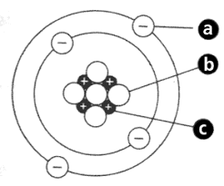

Why are atoms neutral overall?
______________________________________________________________________

EXAMPLE QUESTION
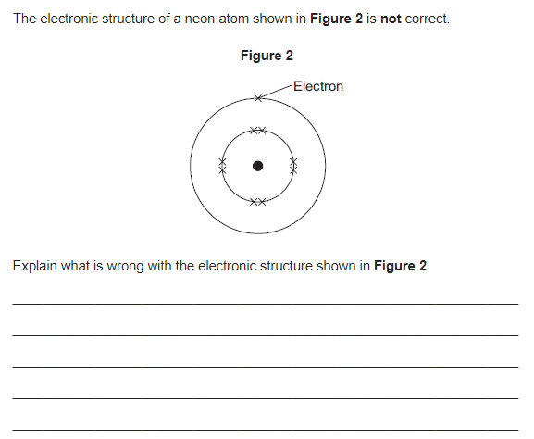

LINKING ATOMIC STRUCTURE AND THE PERIODIC TABLE
What information can we find out about an atom by looking at its position on the periodic table?
List your ideas below:

EXAMPLE QUESTION
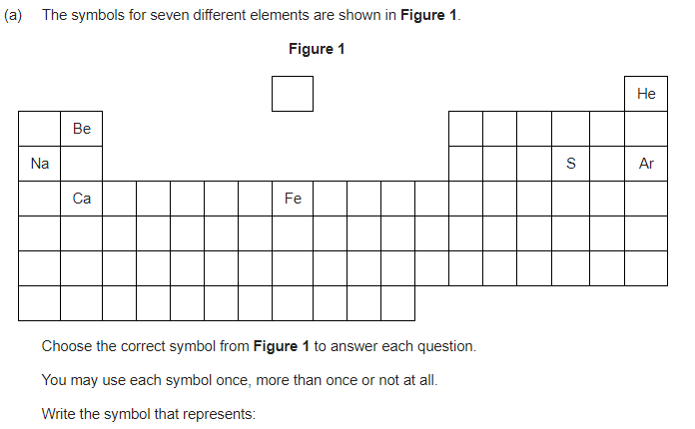
An element with 1 electron in its outer shell
______________________________________________________________________
Two elements with the same number of electrons in their outer shell
______________________________________________________________________
Two elements with the same number of shells ______________________________________________________________________
An element with a full outer shell ______________________________________________________________________

PART 2 CONTENT – STRUCTURE AND BONDING
IONIC BONDS

What can you remember about ionic bonds?

Ionic bonds

Why do elements form bonds with other elements?
____________________________________________________________________________________________________________________________________________

Which elements form ionic bonds?
____________________________________________________________________________________________________________________________________________

What happens to the different elements involved in an ionic bond? Answer in terms of electrons.
____________________________________________________________________________________________________________________________________________

What is an ion?
______________________________________________________________________

EXAMPLE QUESTION
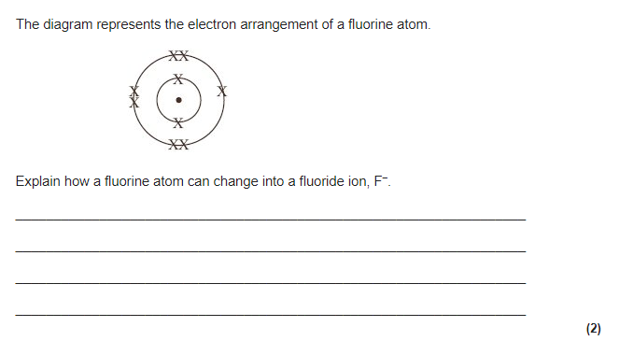

LINKS TO ATOMIC STRUCURE AND PERIODIC TABLE
Use your knowledge of the Periodic table and electronic structures to fill in the table below.

Name of the element | Group number | Number of electrons in the outer shell | How does it obtain a full outer shell | Charge of the ion formed
Potassium
Calcium
Sulphur
Iodine
Neon

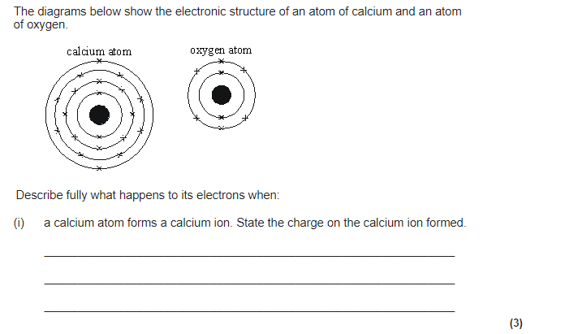
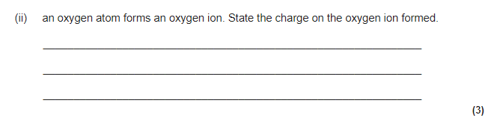

What is an ionic bond?
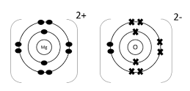
__________________________________________________________________________________________________________________________________________________________________________________________________________________

Describe the structure of an ionic compound.
__________________________________________________________________________________________________________________________________________________________________________________________________________________

EXAMPLE QUESTION
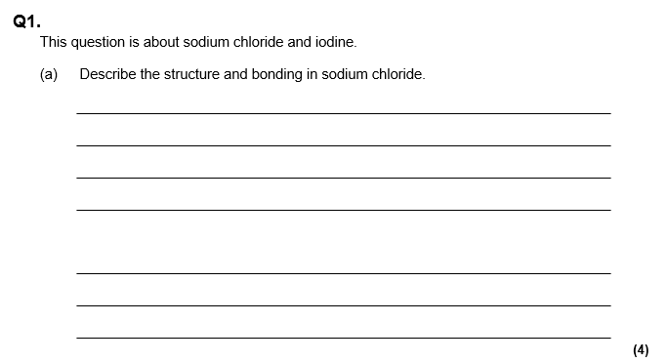

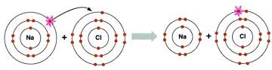
How is sodium chloride produced from sodium and chlorine? Answer in terms of electrons.
_____________________________________________________________________________________________________________________________________________________________________________________________________________________________________________________________________________________________________________________________________________________________

EXAMPLE QUESTION
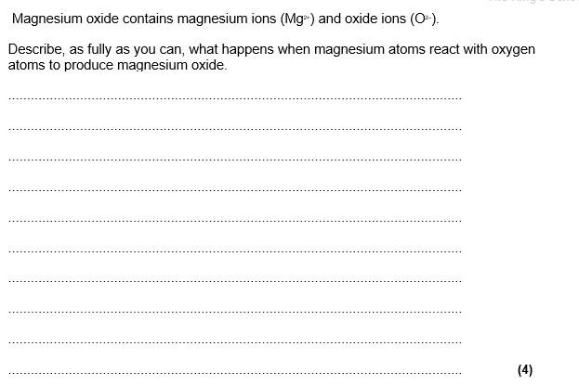
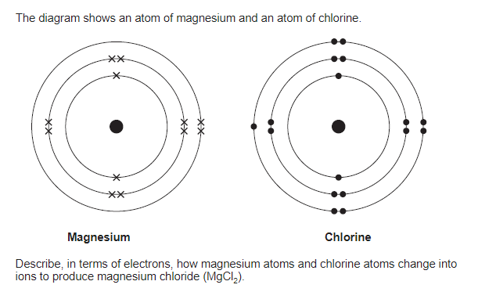

IONIC BONDS AND THEIR PROPERTIES
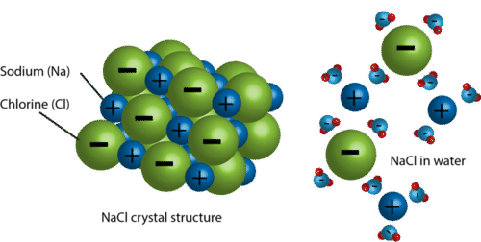
Why do ionic compounds have high melting and boiling points?
________________________________________________________________________________________________________________________________________________________________________________________________________________________________________________________________________________________
Why do ionic compounds dissolve in water?
________________________________________________________________________________________________________________________________________________________________________________________________________________________________________________________________________________________
Why do ionic compounds conduct electricity when molten or dissolved in water but not when solid?
________________________________________________________________________________________________________________________________________________________________________________________________________________________________________________________________________________________

EXAMPLE QUESTIONS
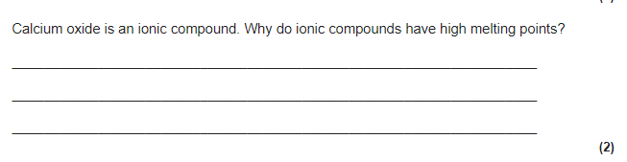

Calcium carbonate has a high melting point and is a solid at room temperature.
As a solid it is unable to conduct electricity, but when melted or dissolved in water it is able to conduct electricity.
Explain In terms of structure and bonding why
Calcium carbonate has a high melting point and is a solid at room temperature (3)
_______________________________________________________________________________
_______________________________________________________________________________
_______________________________________________________________________________
_______________________________________________________________________________
_______________________________________________________________________________
_______________________________________________________________________________
_______________________________________________________________________________
Solid calcium carbonate is unable to conduct electricity (2)
_______________________________________________________________________________
_______________________________________________________________________________
_______________________________________________________________________________
_______________________________________________________________________________
_______________________________________________________________________________
_______________________________________________________________________________
_______________________________________________________________________________
Calcium carbonate is able to conduct electricity when melted or dissolved in water (2)
_______________________________________________________________________________
_______________________________________________________________________________
_______________________________________________________________________________
_______________________________________________________________________________
_______________________________________________________________________________
_______________________________________________________________________________
_______________________________________________________________________________

PART 3 - ELECTROLYSIS
Write down everything you know about electrolysis.

Electrolysis

What is the definition of electrolysis?
__________________________________________________________________________________________________________________________________________________________________________________________________________________

Add labels to the diagram below
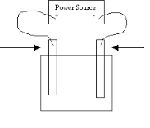

What do we mean by the electrolyte?
____________________________________________________________________________________________________________________________________________

LINKING ELECTROLYSIS TO IONIC COMPOUND PROPERTIES
Electrolysis separates ionic compounds into their original elements using electricity.
Why do ionic compounds need to be molten or dissolved to undergo electrolysis?
__________________________________________________________________________________________________________________________________________________________________________________________________________________

EXAMPLE QUESTION
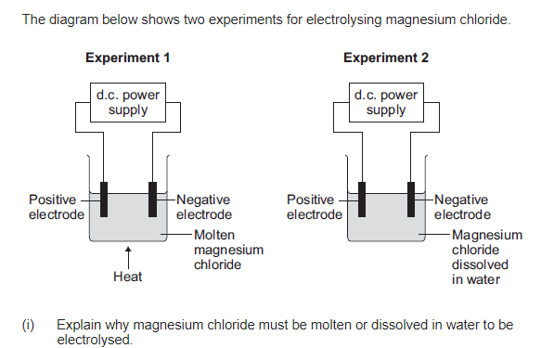
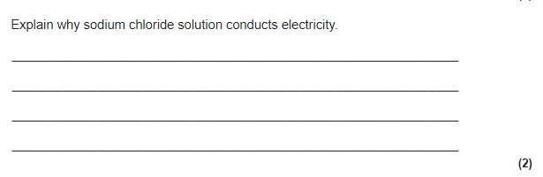
Bonding recap
What is an ion?
____________________________________________________________________________________________________________________________________________
How are metal ions formed?
______________________________________________________________________
How are non-metal ions formed?
______________________________________________________________________
How are the elements formed from their ions during electrolysis?
Metal element:
______________________________________________________________________
Non-metal element:
______________________________________________________________________
Why are metal elements formed at the cathode?
____________________________________________________________________________________________________________________________________________
Why are non-metal elements formed at the anode?
____________________________________________________________________________________________________________________________________________

Fill in the table below:
Name of compound | Element formed at the anode | Element formed at the cathode
Lithium fluoride
Magnesium oxide
Potassium iodide
Sodium chloride
Beryllium bromide

EXAMPLE QUESTION
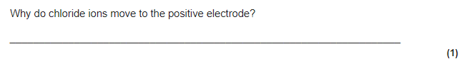

Half equations can also be written to show what happens at each electrode.
Fill in the table below:
Name of compound | Half equation at the anode | Half equation at the cathode
Lithium fluoride
Magnesium oxide
Potassium iodide
Sodium chloride
Beryllium bromide

EXAMPLE QUESTION
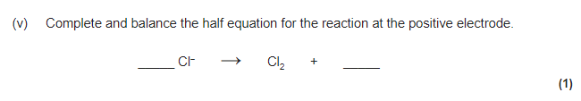
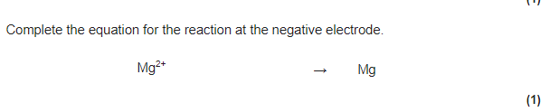
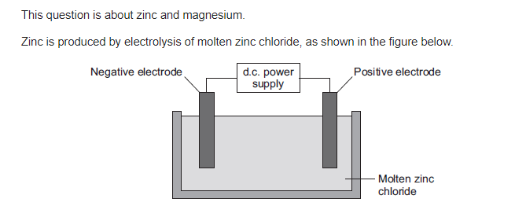
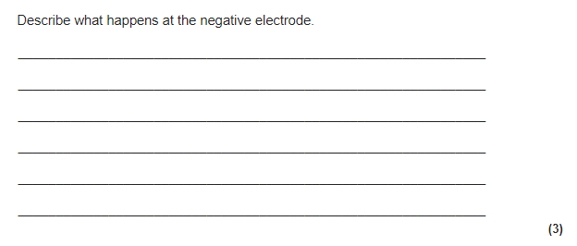

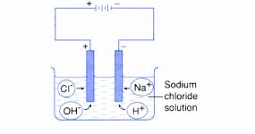
ELECTROLYSIS OF AQUEOUS SOLUTIONS

What does the term aqueous mean?
______________________________________
______________________________________
______________________________________________________________________
State the ions present when the electrolyte is sodium chloride solution.
______________________________________________________________________
Which ions move towards each electrode? Include an explanation.
Anode:
____________________________________________________________________________________________________________________________________________
Cathode:
____________________________________________________________________________________________________________________________________________

Which elements are produced at each during the electrolysis of aqueous solutions when sodium chloride solution is the electrolyte?
Anode
Which ions are attracted towards the anode?
Is a halogen present in the compound?
Is a halogen or oxygen produced?
Cathode
Which ions are attracted towards the cathode?
Is the metal more or less reactive than hydrogen?
Is the metal or hydrogen produce?
